AL KAZUNAH
TISAX Implementation Plan
Readiness Programme, Timeline & Budget
Building on the existing ISO/IEC 27001:2022 ISMS
Document title | TISAX Implementation Plan — Readiness Programme, Timeline & Budget
Prepared for | Al Kazunah
Assessment basis | VDA ISA 6 · Assessment Levels AL1 (self-assessment) + AL2 (remote)
Scheme | TISAX — ENX Association
Date | 16/07/2026
Version | 1.3
Kickoff | Monday, 20 July 2026
Audit-ready | Tuesday, 18 August 2026
AL2 assessment window | 24 August – 18 September 2026 (audit provider calendar)
Classification | Confidential

This plan sets out the activities, owners, timeline, and budget for Al Kazunah to achieve TISAX assessment readiness by 18 August 2026, followed by the AL2 remote assessment and label issuance.

1. Purpose, Objectives & Scope
This plan takes Al Kazunah from kickoff on 20 July 2026 to TISAX assessment-ready by Tuesday, 18 August 2026, leveraging the existing certified ISO/IEC 27001:2022 ISMS. TISAX is the automotive industry’s information security assessment scheme governed by the ENX Association: Al Kazunah is assessed once against the VDA ISA catalogue and can then share the result with any automotive customer through the ENX portal, with labels valid for three years.

1.1 Objectives
- Register Al Kazunah as a TISAX participant with a correctly defined assessment scope on the ENX portal (Week 1).
- Close all gaps between the current ISO 27001 ISMS and the VDA ISA 6 catalogue to maturity level 3 ("Established") for every in-scope control.
- Complete the AL1 self-assessment (VDA ISA 6 workbook) as the internal readiness gate, pass internal audit and management review, and be interview-ready for AL2 by 18 August 2026.
- Contract an accredited audit provider and secure the earliest assessment slot.

1.2 Scope of this plan
- In scope: one Al Kazunah site, one assessment scope, Information Security label. Assessment approach: AL1 self-assessment as the internal gate, followed by an AL2 remote assessment by an accredited audit provider. AL3 (on-site) is explicitly excluded from this plan.
- Conditional: the Data Protection module is activated only if the customer’s requirements letter demands that label. Prototype Protection is excluded — it mandates AL3, which is outside this plan.
- Out of scope: the external assessment itself is performed by the accredited audit provider and follows this readiness programme (Section 6).
Expectation to hold firm: the commitment is audit-ready and registered by 18 August 2026. Label issuance depends on the audit provider’s calendar — typically 4–8 weeks after readiness.

1.3 How AL1 and AL2 fit together in this plan
Level | What it is | Role in this plan
AL1 | Self-assessment: Al Kazunah completes the VDA ISA 6 workbook itself; no auditor verification of content. | Internal readiness gate, 10–13 Aug 2026. Output: completed self-assessment with maturity scores, justifications and evidence references. Note: an AL1 result carries no TISAX label and is generally not accepted by customers as proof — it is the mandatory input to AL2.
AL2 | Remote assessment: the accredited audit provider performs a plausibility check of the self-assessment and evidence, with interviews by web conference. Typically 2–3 audit days. | The label-issuing assessment, window 24 Aug–18 Sep 2026. Sufficient for the Information Security High label (“high” protection needs). If the customer later demands “very high” or prototype labels, AL3 becomes mandatory and this plan must be re-scoped.

1.4 Process overview
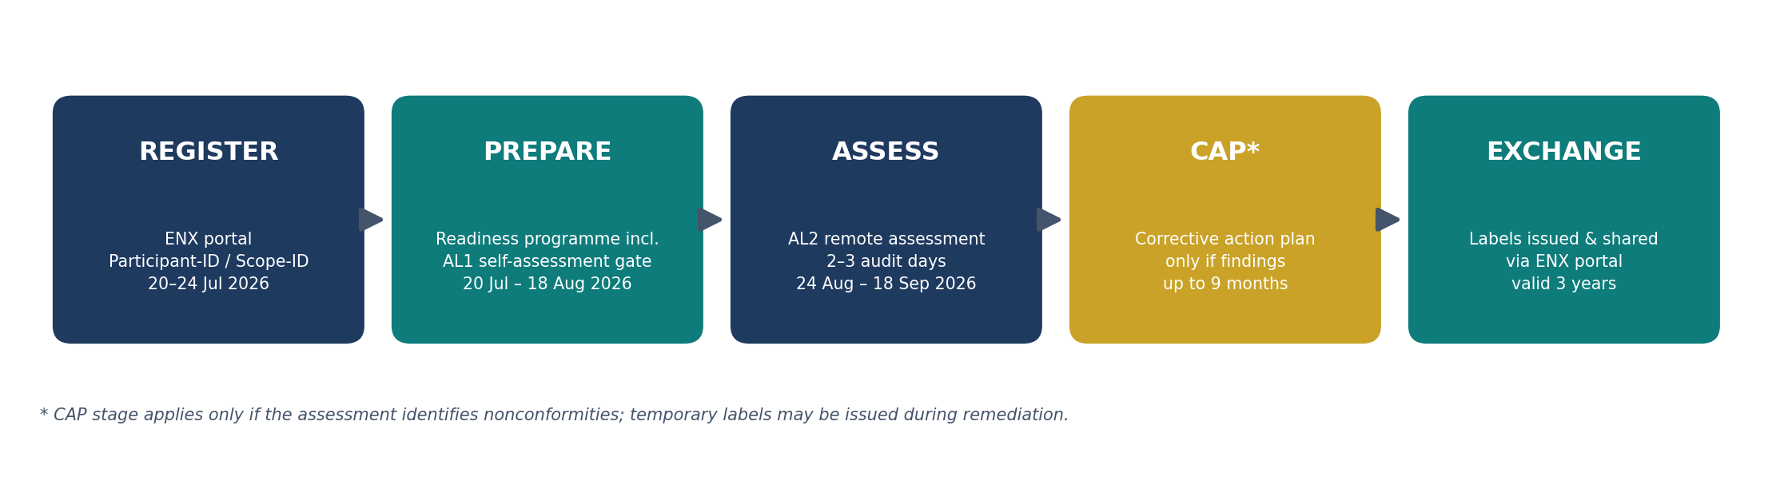

1.5 Schedule at a glance (Gantt)
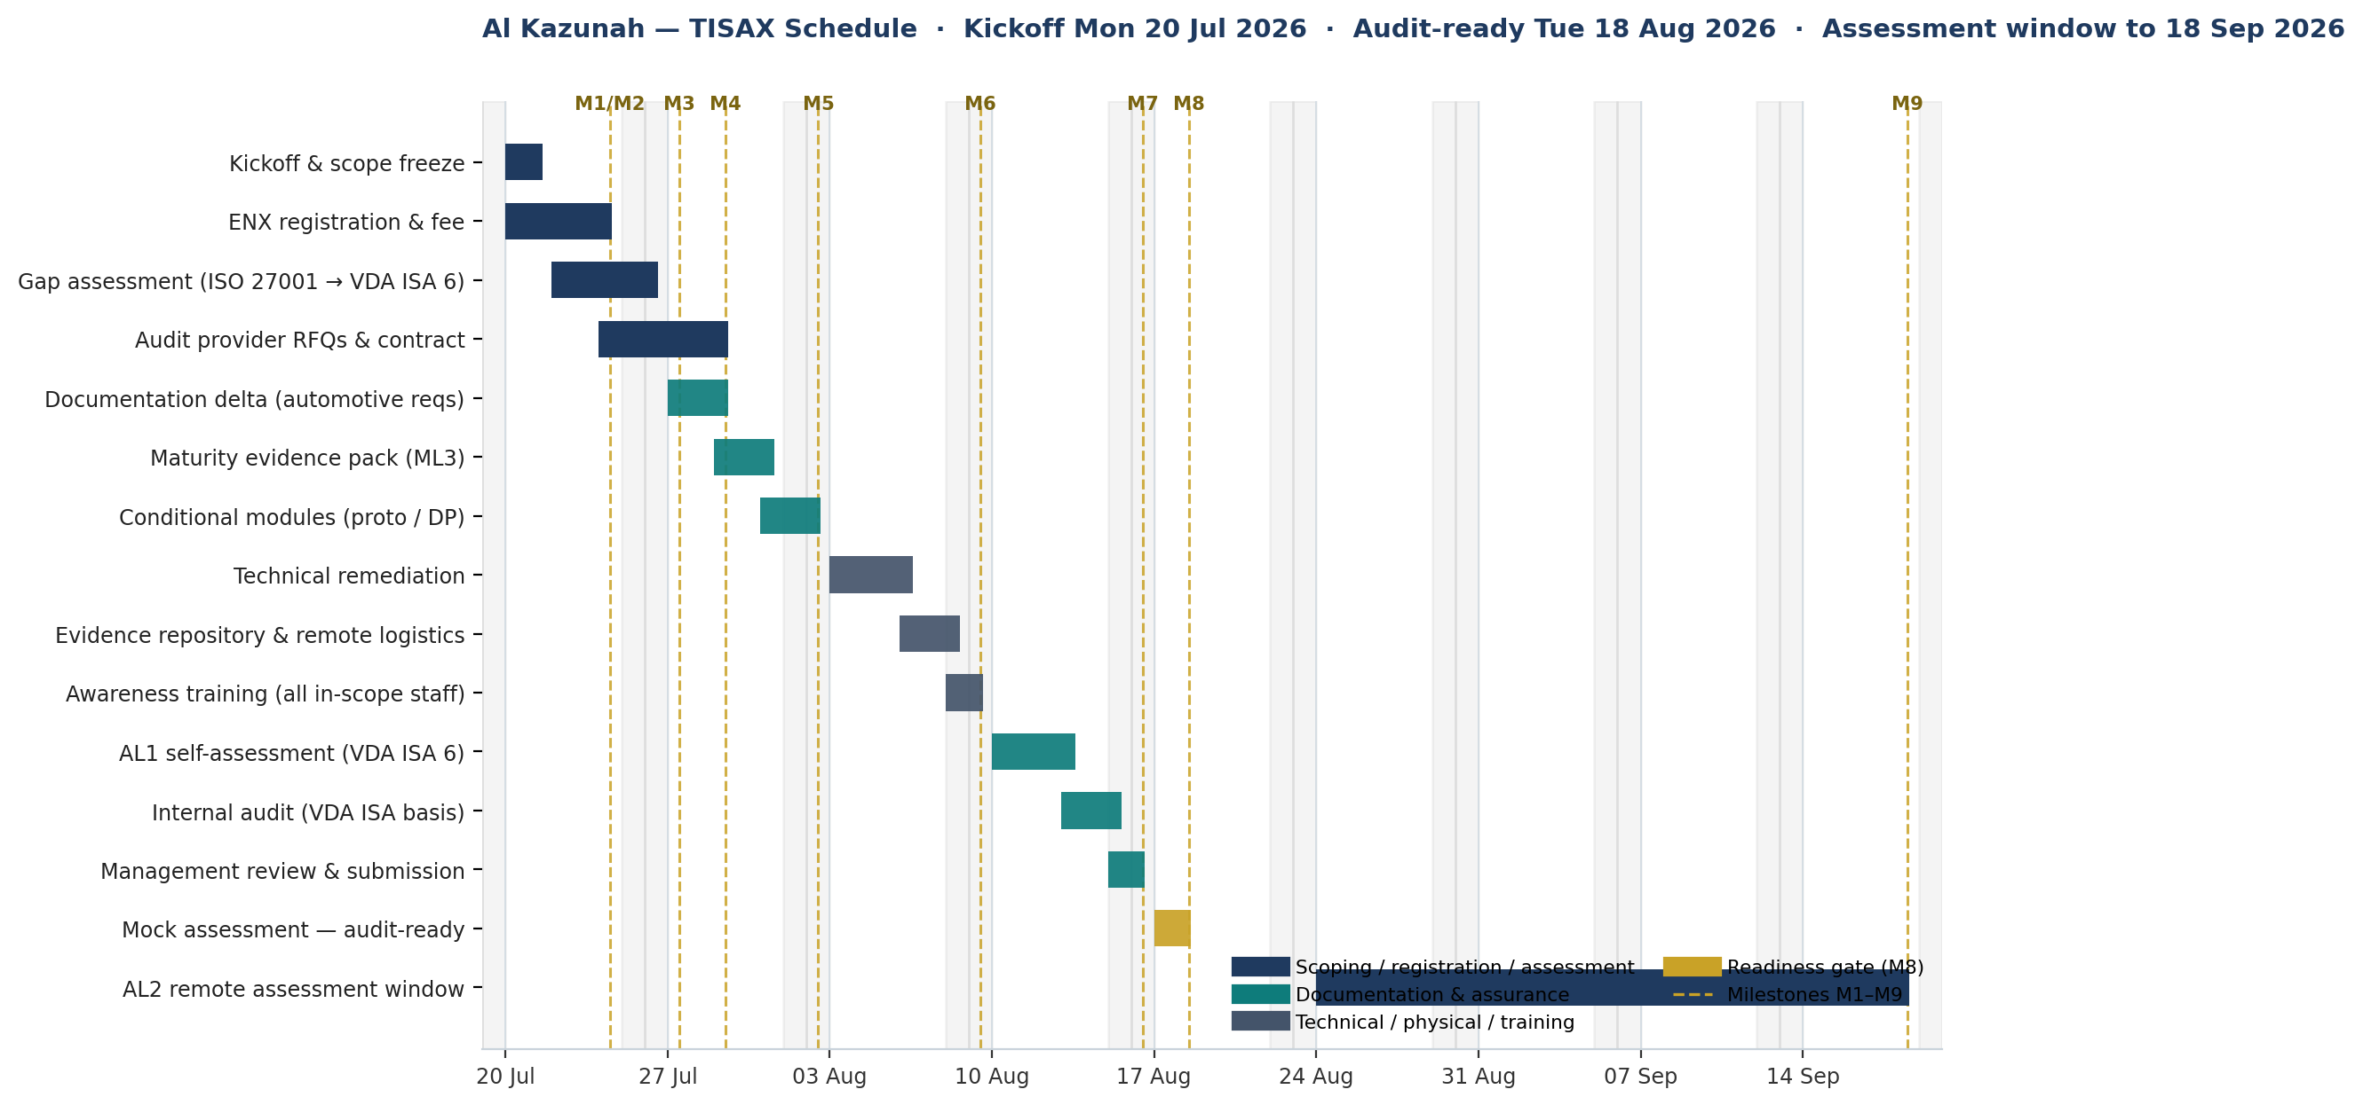
The plan runs on calendar days from kickoff on Monday, 20 July 2026. Where a deadline falls on a UAE weekend (Saturday/Sunday), the deliverable is due the next working day. Amber dashed lines mark milestones M1–M9 (Section 8).

2. Key Decisions Required Before Day 1
Three inputs from the customer’s supplier security requirements letter fix the scope, level, and price. They must be confirmed in writing before the plan starts:
Decision | Options and planning default
Label(s) required | Information Security High (default — achievable at AL2). Data Protection only if demanded. Very High and Prototype Protection labels require AL3 and are excluded from this plan.
Assessment level | This plan delivers AL1 (self-assessment, internal gate) + AL2 (remote assessment, label-issuing) — sufficient for "high" protection needs. Confirm the customer’s letter does not demand "very high" or prototype labels: those mandate AL3 (on-site), which is outside this plan and would require re-scoping.
Site(s) in scope | Planning default: single site, single scope. If multiple sites are combined in one scope, one failing site fails the entire scope — separate scopes are safer where maturity differs.
Terminology note: TISAX has no "Type 1 / Type 2" — that is SOC 2 terminology. The TISAX equivalents are the assessment levels above (AL1/AL2/AL3) and the label types. Where a stakeholder uses SOC 2 language: TISAX maturity level 3 corresponds in spirit to a SOC 2 Type II — the auditor requires evidence the process actually operates over time, not merely that it is designed.

3. Governance, Roles & Responsibilities
Delivery is resourced by a five-person Al Kazunah internal team — Project Lead / ISMS Manager, IT & Security Operations engineer, HR/Administration coordinator, Data Protection Officer (if the DP label is in scope), and an internal auditor — supported by one external TISAX consultant on a fixed fee.
Role | Responsibility in this plan
Project Sponsor (Al Kazunah management) | Approves scope and budget; signs ENX GTCs and audit provider contract; chairs Day 27–28 management review; removes blockers.
Project Lead / ISMS Manager | Day-to-day delivery; owns the delta register, self-assessment, and evidence pack; single point of contact for the audit provider.
IT & Security Operations | Executes technical remediation (Week 3); produces logs, hardening and backup-test evidence.
HR / Administration / Facilities | Training records, visitor management, physical security actions (where AL3/prototype applies).
External TISAX consultant | Gap assessment, documentation delta, AL1 self-assessment support, internal audit, and mock AL2 assessment — fixed fee AED 20,000 (Section 7).
Audit provider (ENX-accredited) | Performs the AL2 remote assessment; approves any corrective action plan; uploads the result to the ENX portal. May not consult.

4. ENX Portal Registration Plan (Days 1–5)
Registration at enx.com → TISAX is the prerequisite for everything else. Output: Participant-ID and Scope-ID, issued 3–5 working days after ENX approval, delivered with the TISAX Registry Excerpt and the accredited audit provider list.
Date (Day) | Task | Owner | Output
Mon 20 Jul (D1) | Assemble registration data: legal entity name, trade licence, registered address, VAT/TRN, invoice address, PO reference, main + deputy TISAX contacts. Note: charging model and VAT ID cannot be corrected online later — errors require contacting ENX by phone/email. | Project Lead | Registration data sheet
Mon 20 Jul (D1) | Confirm authorised signatory for the TISAX Participation General Terms & Conditions (full legal capacity required). | Sponsor | Signatory confirmed
Tue 21 Jul (D2) | Complete online registration: participant data, accept GTCs, define assessment scope using the standard scope wording; select site, label(s), and AL2 as the assessment level. | Project Lead + Sponsor | Registration submitted
21–24 Jul (D2–5) | Pay the ENX registration invoice (one-time per site per scope; payment is a prerequisite for final acceptance; terms 30 days). | Finance | Fee settled
22–24 Jul (D3–5) | On receipt of Scope-ID: issue RFQs to at least three audit providers from the ENX list — compare day rates, regional auditor availability (travel cost), and earliest assessment window. | Project Lead | Three quotations
24–29 Jul (D5–10) | Select and contract the audit provider; book the assessment slot immediately — provider lead time is the single largest schedule risk. | Sponsor | Assessment date secured

5. Work Plan & Timeline

Week 1 — Scoping, registration & gap assessment (20–26 July 2026)
Dates (Days) | Task | Owner | Deliverable
20–21 Jul (D1–2) | Kickoff; confirm customer requirements letter (labels, protection needs, AL); freeze scope; run the registration plan (Section 4). | Project Lead | Scope sign-off
22–26 Jul (D3–7) | Gap assessment: map the ISO 27001 Statement of Applicability and records to VDA ISA 6 control by control; score current maturity 0–5; log every gap in a delta register with owner and due date. | Consultant + Project Lead | Gap report & delta register
24–26 Jul (D5–7) | Quick-win remediation begins on gaps closable within days (record-keeping, minor policy edits). | Control owners | Early closures

Week 2 — Documentation & evidence build (27 July – 2 August 2026)
Dates (Days) | Task | Owner | Deliverable
27–29 Jul (D8–10) | Extend the ISMS for automotive-specific requirements: information classification aligned to OEM protection-need classes, handling of customer-provided information, supplier/subcontractor flow-down, customer incident-reporting commitments, mobile & teleworking rules. | Consultant + ISMS Manager | Updated policy set
29–31 Jul (D10–12) | Build the maturity evidence pack: for every control targeting ML3, attach proof of operation — tickets, logs, review minutes, training and access-review records. This is the decisive workstream: ISO-certified organisations fail TISAX on evidence, not policy. | All control owners | Evidence index
31 Jul–2 Aug (D12–14) | Conditional module if in scope — Data Protection: records of processing, data processing agreements, technical & organisational measures mapped to the VDA ISA DP module. | DPO / ISMS Manager | DP module pack

Week 3 — Technical remediation & remote-assessment readiness (3–9 August 2026)
Dates (Days) | Task | Owner | Deliverable
3–6 Aug (D15–18) | Close technical deltas: hardening evidence, network segregation documentation, cryptography inventory, logging & monitoring records, backup and restore-test evidence. | IT & Security Ops | Technical deltas closed
6–8 Aug (D18–20) | AL2 remote-assessment logistics: consolidate all evidence into a structured, screen-shareable repository indexed per VDA ISA control; test the web-conference setup and screen-sharing of evidence. | Project Lead + IT | Evidence repository live
8–9 Aug (D20–21) | Awareness session for all staff in the assessed scope, with attendance records — the auditor interviews staff at random. | HR + ISMS Manager | Training records

Week 4 — Self-assessment, internal audit & readiness (10–18 August 2026)
Dates (Days) | Task | Owner | Deliverable
10–13 Aug (D22–25) | AL1 self-assessment: complete the official VDA ISA 6 workbook — maturity score, justification, and evidence reference for every in-scope control. This constitutes the AL1 result and the mandatory input to AL2. | Project Lead + Consultant | AL1 self-assessment file
13–15 Aug (D25–27) | Internal audit against VDA ISA 6 (adapting the existing ISO 27001 internal audit programme); close residual findings. | Internal auditor / Consultant | Internal audit report
15–16 Aug (D27–28) | Management review and sign-off; submit the self-assessment to the audit provider; confirm assessment logistics. | Sponsor | Review minutes
17–18 Aug (D29–30) | Mock AL2 assessment: dry-run remote interviews by web conference with process owners and sampled staff; rehearse on-screen evidence retrieval so nothing is searched for live. | Consultant | Readiness confirmation

6. External Assessment & Label Issuance
Stage | What happens | Indicative timing
AL2 remote assessment | The audit provider reviews the AL1 self-assessment and evidence and conducts interviews by web conference — typically 2–3 audit days, no site visit, no travel costs. | 24 Aug – 18 Sep 2026 (provider calendar)
Result — no findings | Labels issued; result uploaded to the ENX portal, initially visible only to Al Kazunah. | With final report (target by 25 Sep 2026)
Result — findings | Corrective action plan approved by the auditor; temporary labels may be issued; up to 9 months to close; follow-up assessment converts to full labels. | CAP window (up to 9 months from report)
Exchange | Al Kazunah creates sharing permissions per customer (or publishes within TISAX); disclosure depth is controlled per partner (report sections A–E). Nothing is visible without explicit release. | Immediately after issuance (target Sep–Oct 2026)
Validity & renewal | Labels valid 3 years; renewal typically costs 60–70% of the initial effort; begin renewal preparation at month 30. | Month 30 ≈ Mar 2029 (labels expire ≈ Sep 2029)

7. Budget

7.1 External costs
Item | Budget | Notes
ENX registration fee | ≈ €475–500 per site per scope (≈ AED 2,000) | One-time; no recurring ENX fees during the 3-year validity.
Audit provider — AL2 (remote) | €1,200–1,500/day × 2–3 days ≈ €2,400–4,500 (≈ AED 10,000–19,000) | One site, one label scope; fully remote — no auditor travel costs. AL1 has no external cost (internal effort only).
Each additional site or label | +1–2 audit days (≈ €1,200–3,000) | Scope strictly to the customer’s letter.
Follow-up assessment (contingency) | 1–2 audit days | Only if a corrective action plan is required; mitigated by the Day 29–30 mock assessment.

7.2 Consulting & internal effort
Item | Budget | Notes
External TISAX consultant | AED 20,000 (fixed) | Gap assessment, documentation delta, evidence pack, AL1 self-assessment support, internal audit, mock AL2 assessment.
Al Kazunah internal effort | 5-person team · ≈ 15–25 person-days total | Project Lead/ISMS Manager, IT & Security Ops, HR/Admin, DPO, internal auditor — part-time alongside normal duties; materially reduced by the existing ISO 27001 ISMS.
GRC tool — Sprinto (optional) | Subscription — per Sprinto quote | Automates evidence collection and control monitoring, and streamlines the VDA ISA self-assessment versus spreadsheets; also reusable for the existing ISO 27001 ISMS. Decision by M1; not on the critical path.

7.3 Planning totals
- Single site · AL1 + AL2 · Information Security label · ISO 27001 in place: ≈ AED 32,000–41,000 external costs (ENX ≈ 2,000 + AL2 audit 10,000–19,000 + consultant 20,000), plus the optional Sprinto subscription and internal effort.
- If the customer later mandates AL3 (very high / prototype): re-scope required — add ≈ AED 15,000–32,000+ audit fees plus travel and physical-security preparation.
- Renewal (year 3): typically 60–70% of initial cost; 4–8 weeks of preparation.

8. Milestones
Milestone | Definition of done | Deadline
M1 | Scope frozen; ENX registration submitted; fee paid. | Fri 24 Jul 2026 (D5)
M2 | Participant-ID & Scope-ID received; audit provider RFQs issued. | Fri 24 Jul 2026 (D5)
M3 | Gap report and delta register approved. | Mon 27 Jul 2026 (D7→next working day)
M4 | Audit provider contracted; assessment date booked. | Wed 29 Jul 2026 (D10)
M5 | Documentation delta and evidence pack complete. | Mon 3 Aug 2026 (D14→next working day)
M6 | Technical & physical remediation closed; awareness delivered. | Mon 10 Aug 2026 (D21→next working day)
M7 | AL1 self-assessment submitted; internal audit and management review complete. | Sun 16 Aug 2026 → Mon 17 Aug (D28)
M8 | Mock AL2 assessment passed — Al Kazunah is audit-ready. | Tue 18 Aug 2026 — AUDIT-READY GATE
M9 | AL2 remote assessment performed; labels (or CAP) issued. | 18 Sep 2026 (end of assessment window)

9. Assumptions & Risks

9.1 Assumptions
- The ISO 27001:2022 ISMS is certified and operating, and its scope covers the site and processes to be registered in TISAX; a wider TISAX scope enlarges the delta and the budget.
- Single site, single scope, Information Security High label, delivered via AL1 self-assessment plus AL2 remote assessment. The customer’s requirements letter does not demand “very high” protection needs or prototype labels (which would mandate AL3).
- The assessment is ordered in 2026 on the VDA ISA 6 basis (ISA 7 applies to assessments ordered from 2027-01-01).
- Staff and records are available on the days planned; the Sponsor resolves resourcing conflicts within 48 hours.

9.2 Risks & mitigations
Risk | Impact | Mitigation
Audit provider lead time | Label date slips by weeks | RFQ three providers on Day 3–5; book the slot at contract signature (M4, Day 10).
Registration data errors (charging model, VAT ID) | Invoice/registration delay; cannot be fixed online | Data sheet completed and checked on Day 1 before entering the portal.
Evidence gaps at ML3 | Findings and a corrective action plan | Evidence pack as the Week-2 priority; internal audit Day 25–27; mock assessment Day 29–30.
Scope creep (extra labels/sites) | Cost and timeline growth | Scope frozen at M1 strictly to the customer’s letter; changes via Sponsor approval only.
Customer demands AL3 after kickoff | Re-scope: on-site assessment, physical security preparation, higher fees | Written confirmation of protection needs and labels obtained before Day 1 (Section 2); AL3 exclusion stated in the scope sign-off.
Multi-site combined scope | One failing site fails the whole scope | Default to a single-site scope; register additional sites as separate scopes where maturity differs.

