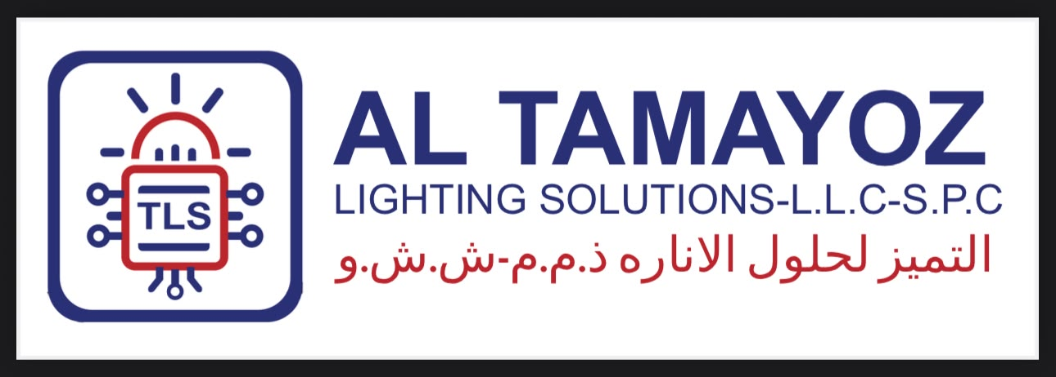


30 July 2026
Company name:
AL TAMAYOZ LIGHTING SOLUTIONS - L.L.C - S.P.C

Company scope:
- Installation and maintenance of alternative energy equipment
- Retail trading in alternative energy equipment and accessories
- Retails Sale of Lighting Tools and Accessories

(Cont)
Company Name:
  AL TAMAYOZ LIGHTING SOLUTIONS-L.L.C-S.P.C
Contact Person: | Shanoos Muhammed
Designation: | QC
Tel no: | +971 2 62 66 217
Email address:
  sales@tamayozlighting.ae
Location: | DUBAI
Standard: | 9001/45001
If they ask for lead auditor or Internal audit training / Awareness Training: | NO
Validity: | 3 years
Urgent or normal process: | URGENT
Marketing Commitments: | INITIAL

