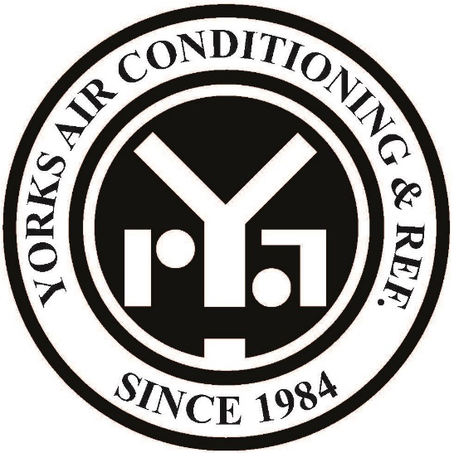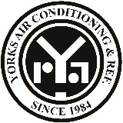

14 Aug 2026
Company name:
YORKS AIRCONDITIONING AND REFRIGERATION - L.L.C - S.P.C
Company scope:
- Air Conditioning, Ventilation Air Cooling Systems Maintenance, Installation and Contracting
- Onshore And Offshore Oil And Gas Fields And Facilities Services
- Installation and repair of safety equipment and fire extinguishing systems
- Wholesale of Air-Conditioner and Coolant Spare Parts Trading
- Fire Retardant Lining Materials Installation
- Wholesale of Unit Air-Conditioner Trading

(Cont)
CEO & PRESIDENT

Request for Intercom, Initial Client (Ria)

Contract Reference #: | QRS-IMS4571#1
Contract Date: | August 7,2026
Company Name: | YORKS AIRCONDITIONING AND REFRIGERATION - L.L.C - S.P.C
Contact Person: | Ms. Hamda
Designation: | Management Representative
Tel no: | 025509788
Email address: | hamda@yorks.ae
Location: | Abu Dhabi
Standard: | ISO 9001
Accreditation: | ASCB
Validity: | 1 year
Initial or Recertification: | Initial
Urgent or normal process: | Urgent
Category | C (no documents)

