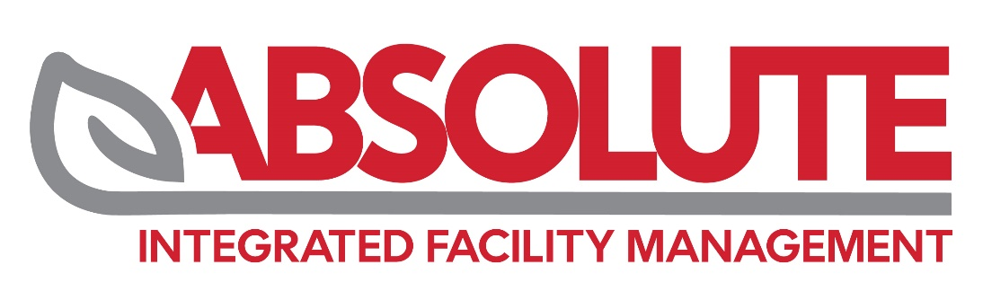
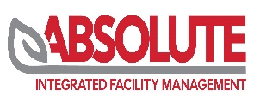

20 Aug 2026
Company name:
ABSOLUTE INTEGRATED FACILITY MANAGEMENT - L.L.C - S.P.C
Company scope:
- Management and Operation of Public Utilities
- Onshore And Offshore Oil And Gas Fields And Facilities Services

(Cont)

Dear
Request for Intercom initial Client (Mary)
Company Name: | ABSOLUTE INTEGRATED FACILITY MANAGEMENT - L.L.C - S.P.C
Contact Person: | Mr. Habeeb
Designation: | Management Representative
Tel no: | 050 795 3980
Email address: | habeeb@absolutefm.ae
Location: | Abu Dhabi
Standard: | ISO 9001:2015
Surveillance | 3 Years
Accreditation: | ASCB Accreditation
If Recertification (Y/N) | Initial
Urgent or normal process: | Very urgent Process

