
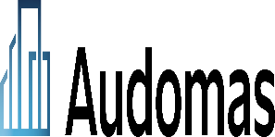

26 Aug 2026
Company name:
AUDOMAS BUILDING FACADES SERVICES L.L.C
Company scope:
- Industrial Facilities’ Installations Inspection Engineering services
- Building Facades Cladding Engineering Design
- Buildings & Civil Works Inspection Engineering services
- Building Maquette & Model Makers

(Cont)

Request for Intercom, Initial Client (Ria)

Contract Reference #: | QRS-IMS4469#2
Contract Date: | July 3,2026
Company Name: | AUDOMAS BUILDING FAÇADE SERVICES LLC
Contact Person: | Mr. Michael Hills
Designation: | Chief Growth Officer
Tel no: | +971 50 120 9456
Email address: | michael.h@audomas.com
Location: | Dubai
Standard: | ISO 9001, ISO 14001, ISO 45001 & ISO 27001
Accreditation: | ASCB
Validity: | 1
Initial or Recertification: | Initial
Urgent or normal process: | Urgent
Category | C (no documents)

