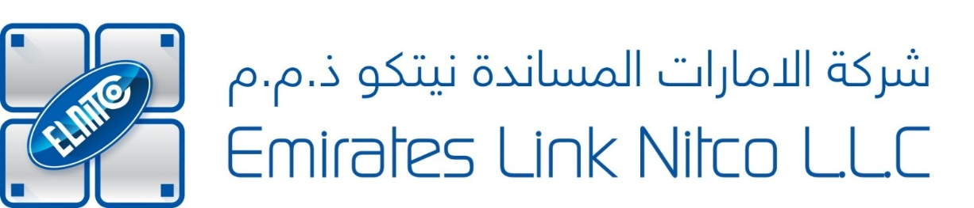
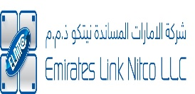

11 Sep 2026
Company name:
EMIRATES LINK NITCO – LLC
Company scope:
- Transportation of Organic Waste
- Sanitary Sewer Networks Maintenance
- Irrigation Network Contracting
- Main Roads, Streets and Related Works Contracting
- Road Maintenance
- Water Desalination and Treatment Plants Operation and Maintenance
- Onshore And Offshore Oil And Gas Fields And Facilities Services
- Afforestation Contracting
- Mechanical Contracting
- All Kind Building Projects Contracting
- Contracting Transmission Networks and Distribution of Water
- Irrigation Systems Operation For Agricultural Purposes
- Main Sewerage Networks Contracting
- Electrical Contracting
- Submain Sewerage Networks and Houses Connection Contracting
- Sewerage Treatment Stations Contracting
- Buildings Maintenance
- Rain Water Drainage Contracting
- Landscape And Gardening Services
- Waste Water Transportation

(Cont)

MANAGING DIRECTOR

Company Name: | EMIRATES LINK NITCO LLC
Contact Person: | Mr. Altaf Ansari
Designation: | QA/QC Manager
Tel no: | 056 422 2913
Email address: | altaf.ansari@elnitco.ae
Location: | Ittihad International Investment Complex, Office no. 1, PO Box 44656, Plot No. 41, Mussafah M15, Abu Dhabi, UAE.
Standard: | ISO 22301:2019 (BCMS)  ISO 50001:2018 (EnMS)
If they ask for lead auditor or Internal audit training / Awareness Training: | NONE
Validity: | 1 year
Urgent or normal process: | TOP URGENT
Marketing Commitments: | Please prepare proper documents. If any clarification, please contact the client before sending the documents to them.

