QUALITY REGISTRAR SYSTEMS
Empowering continual improvement for your business

Certification &
Audit Platform
by Quality Registrar Systems
COMPLETE USER MANUAL
Version 2.1 • May 2026
ALTAYABOON INFORMATION TECHNOLOGY NETWORK SERVICES L.L.C
National Cinema - Al Danah - Zone 1 - Abu Dhabi, UAE
contact@altayaboon.com | +971 5632 96231

Table of Contents
1. | Introduction
2. | System Overview
3. | Getting Started — Authentication
3.1 | User Registration (with OTP)
3.2 | Login
3.3 | Forgot Password / Password Reset
3.4 | Admin Verification of New Users
3.5 | Role & Permission Assignment
4. | Dashboard — All Modules at a Glance
5. | Module — User Management
6. | Module — Companies (Client)
7. | Module — Inquiries (Proceeding)
9. | Module — Audit Compliance
9A. | Module — Audit Schedule (Coordinator — In Development)
10. | Module — Standards
11. | Module — Countries
12. | Module — Templates (Stage 1 & 2)
13. | Module — Job Registrar
14. | Module — Certificate (Draft + Digital)
14A. | Module — Chat (Internal Messaging)
15. | Module — Previous Certificates
16. | Module — Settings
17. | End-to-End Document Generation Flow
18. | Recommended Document Naming Convention

1. Introduction

Welcome to the Quality Registrar Systems Certification & Audit Platform — a complete ERP solution that streamlines every step of the certification lifecycle: client onboarding, inquiries, auditor assignment, audit scheduling, document generation for Stage 1 and Stage 2, certificate issuance (draft + digital), and ongoing surveillance.

Purpose of This Manual
- Walk every user — from a brand-new sign-up to a Super-admin — through each module step by step.
- Show what every screen looks like with real screenshots and explain every field on every form.
- Define roles and permissions so admins can keep the platform secure and accurate.
- Establish a consistent naming convention for every audit document the platform produces.

How to Read This Manual
Start with Section 3 (Authentication) to create your account and sign in. Then read Section 4 (Dashboard) to see every module on one screen. After that, jump to the module sections (5 – 16) that match your role. Each module section follows the same structure: Purpose → Access → List View → Forms → Step-by-step instructions → Tips.

2. System Overview

The Platform is organised around a central Dashboard from which every module is one click away. The platform is role-based — each user only sees the modules and actions appropriate to their job function. The table below lists every module covered in this manual.
Module | What It Does
User Management | Add users, verify new sign-ups, assign roles and granular permissions.
Companies | Master record of every client organisation that is audited or certified.
Inquiries | Captures new business leads / requests for certification.
Audit Compliance | Tracks every audit, its stage, status and linked documents. Used by the Scheme Department to generate Stage 1 / Stage 2 audit pack documents.
Audit Schedule (In Dev) | Coordinator's real-audit scheduling: pick date, lead auditor and mode for each row; notify Marketing, Auditor and Coordinator; reschedule and cancel with audit trail. Currently in development.
Standards | Master list of supported certification standards (ISO 9001, 14001, 45001, …).
Countries | Country directory for client locations and regulatory mapping.
Templates | Library of Stage 1 / Stage 2 audit document templates and their content.
Job Registrar | Each audit becomes a Job here — assigned, tracked and completed.
Certificate | Generates Draft and Digital certificates after Stage 2 closure.
Chat | WhatsApp-style internal messaging between Marketing, Coordinator, Scheme Dept. and Auditors. Send text, files, QR codes and shared record cards from any module.
Previous Certificates | Historical archive of certificates imported from legacy systems.
Settings | Platform-wide configuration, notifications, branding.

3. Getting Started — Authentication

Before any work can be done in the Platform, every user must have a verified account with a role assigned. The platform follows a secure two-step onboarding process: the user self-registers (with OTP email verification), then an administrator verifies the account and grants the appropriate role and permissions.

3.1 User Registration (with OTP)
New employees create their own account from the Create Account page. The platform asks only for the essentials — name, work email and a password — and immediately sends a One-Time Password (OTP) to the work email to confirm the user really controls that mailbox.
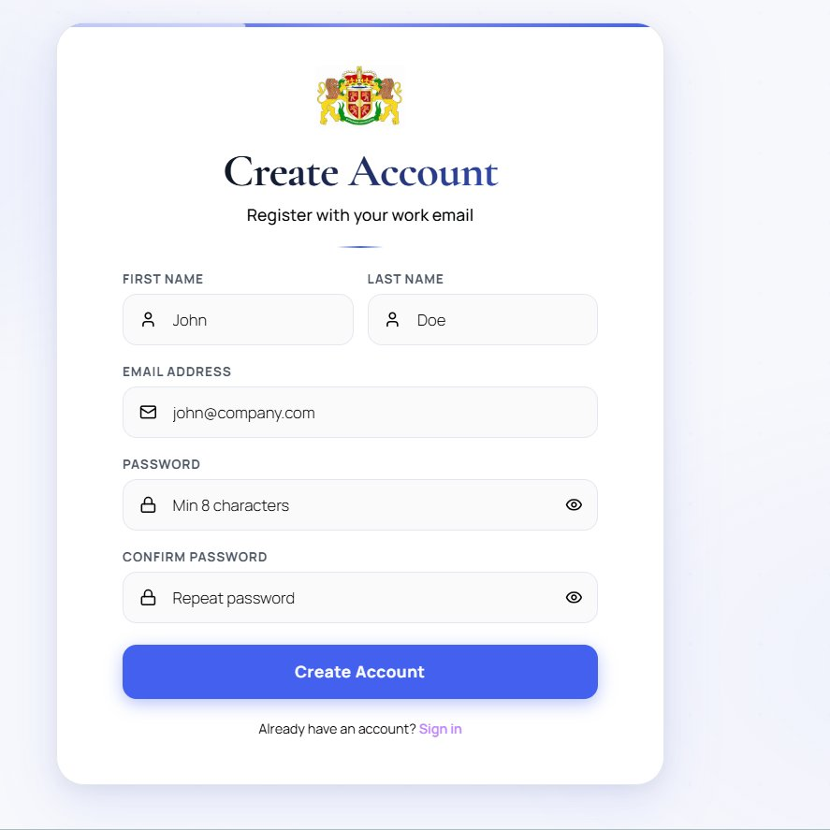
Figure 3.1 — Create Account form.
Step 1 ▸ Open the Create Account page
From the login page, click the Create Account link at the bottom.
Step 2 ▸ Enter your name
Type your First Name and Last Name in the two side-by-side fields (e.g. John / Doe).
Step 3 ▸ Enter your work email
Type your company email address (e.g. john@company.com). Personal addresses are not permitted.
Step 4 ▸ Set a password
Type a password of at least 8 characters in the Password field, then repeat it in Confirm Password. Use the eye icon to toggle visibility.
Step 5 ▸ Submit
Click the blue Create Account button. The system sends a 6-digit OTP to your work email.
Step 6 ▸ Verify the OTP
Open the email titled “Confirm your account”, copy the 6-digit code, paste it on the verification screen, and click Verify. Your password is now active.
ℹ The OTP is valid for 10 minutes. If it expires, click Resend OTP on the verification screen.

3.2 Login
Once the email is verified, the user can sign in from the Welcome Back screen. Until the admin verifies the account, the user will see a banner indicating their account is Pending Verification and most modules will be read-only or hidden.
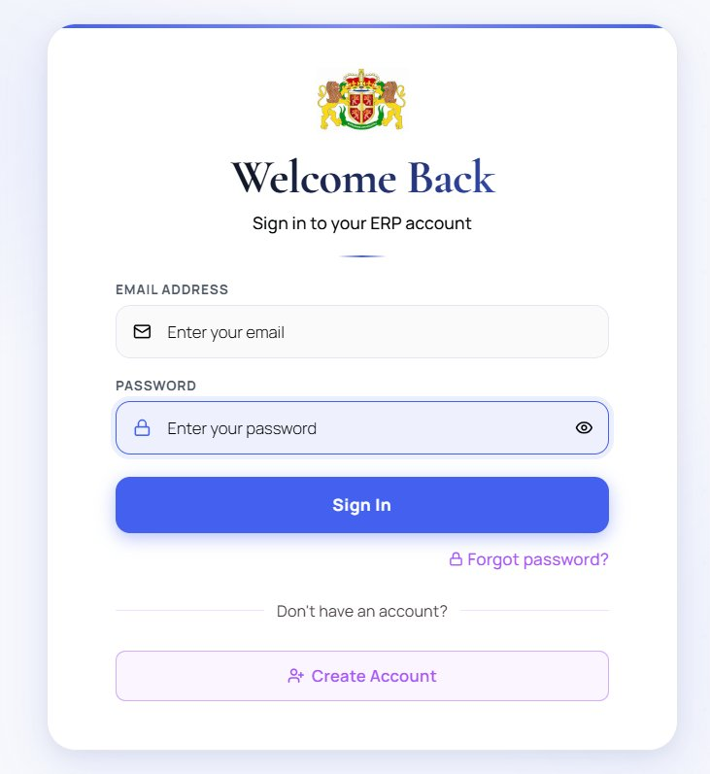
Figure 3.2 — Login screen (Welcome Back).
Step 1 ▸ Open the Platform URL
Navigate to the platform login page in your browser (e.g. web.qrsyst.com).
Step 2 ▸ Enter credentials
Type your work email and password in the two fields.
Step 3 ▸ Sign In
Click the blue Sign In button. If credentials are correct, you land on the Dashboard (Section 4).
Step 4 ▸ Pending account?
If your account is Unverified or Pending Approval, contact a Super-admin — see Section 3.4.

3.3 Forgot Password / Password Reset
Users can reset their own password without administrator help. The flow uses the same OTP mechanism as registration, so only the owner of the work email can reset the password.
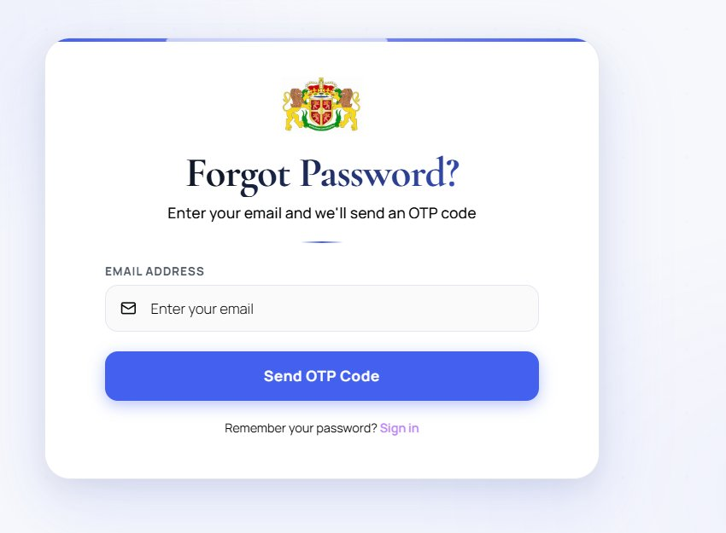
Figure 3.3 — Forgot Password screen.
Step 1 ▸ Click Forgot Password
On the login page, click the purple Forgot password? link.
Step 2 ▸ Enter your work email
Type your email and click the blue Send OTP Code button.
Step 3 ▸ Check your inbox
Open the OTP email from the platform and copy the 6-digit code.
Step 4 ▸ Set new password
Return to the platform, enter the OTP, then type your new password twice and click Reset Password.
⚠ For security, after 5 failed login attempts the account is locked for 15 minutes. Wait or use Forgot Password to recover access.

3.4 Admin Verification of New Users
Even after the user has verified their email via OTP, the account remains in Unverified / Pending Approval state until an administrator with the Super-admin role approves it. This second gate ensures that only authorised personnel can act inside the certification system.

Admin Step-by-Step
- Sign in as a Super-admin and open User Management → All Users.
- Filter Status = Unverified (or Pending Approval) to find new sign-ups.
- Click the Eye icon to review the user's profile (name, email, joined date).
- If legitimate, click the Verify action (green tick) to mark the account as Active.
- If suspicious, click Delete (red bin) to remove the account entirely.

3.5 Role & Permission Assignment
Once an account is verified, the admin assigns one or more roles. Roles map to job functions — Auditor, Marketing, Scheme Coordinator, Super-admin. Each role carries a default permission set, but the admin can fine-tune permissions per user from User Permissions or globally from the Permission Matrix.

Standard Roles in the Platform
Role | Typical Access
Super-admin | Full access to every module, user management, settings, and override actions.
Scheme Coordinator | Manage Companies, Inquiries, schedule audits, generate certificates.
Auditor | View assigned jobs, fill audit checklists, upload audit documents, raise NCRs.
Marketing | Manage Inquiries and Companies records; no audit or certificate actions.
Read-only / Viewer | Read access to dashboards and reports only — no edit rights.

Assigning a Role
- Open User Management → All Users.
- Locate the user and click the Key icon under Actions.
- Tick one or more roles (e.g. Auditor, Marketing). Multiple roles are permitted.
- Optionally open User Permissions to grant or revoke specific actions for that user only.
- Click Save. The user is notified by email and can now access the granted modules.

4. Dashboard — All Modules at a Glance

After signing in, every user lands on the Dashboard. This is the first page of the platform and presents every module on a single screen. The Dashboard greets the user by name, shows the current date and active role, and presents twelve summary tiles — one per module — each showing the live record count. Beneath the tiles you'll find Recent Activity and Jobs This Year.
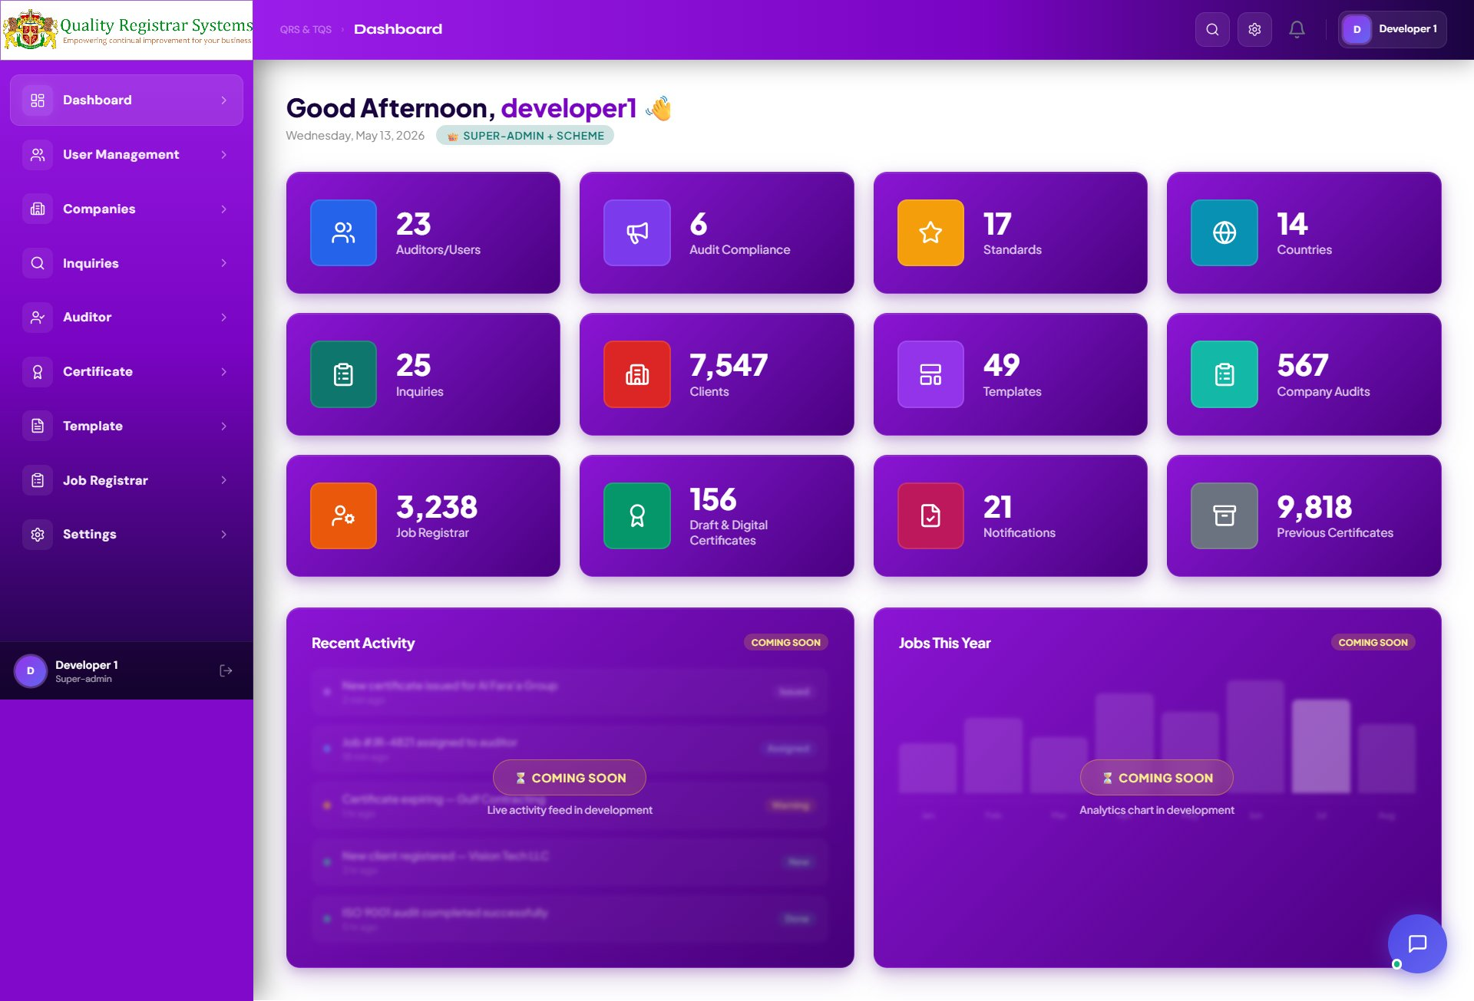
Figure 4.1 — The Dashboard, shown immediately after login. Every module is one click away.

Reading the Tiles
Tile | Meaning
Auditors / Users | Total registered platform users across all roles.
Audit Compliance | Open audit compliance records currently being tracked.
Standards | Certification standards configured in the system.
Countries | Countries available for client / auditor location selection.
Inquiries | Active inquiries / leads in the pipeline.
Clients | Total client companies registered in the platform.
Templates | Stage 1 / Stage 2 templates available in the library.
Company Audits | Total audits executed across all companies.
Job Registrar | Total job records (each audit cycle creates one job).
Draft & Digital Certs | Active certificates issued, both draft and digital.
Notifications | Unread notifications for the current user.
Previous Certificates | Historical certificate archive imported from legacy systems.

Sidebar Navigation
The left sidebar provides direct access to every module. Click any module to expand its sub-pages (e.g. Companies → All Companies / Reports). The currently selected module is highlighted in white. Each section below corresponds to one sidebar item, in the same order they appear in the platform.
✓ Click any tile or sidebar item to jump into that module. Tile counts update in real time as records are added or removed.

5. Module — User Management

User Management is the control centre for everyone who can log into the Platform. From here, administrators search and filter users, verify pending accounts, assign or revoke roles, and inspect the live permission matrix.
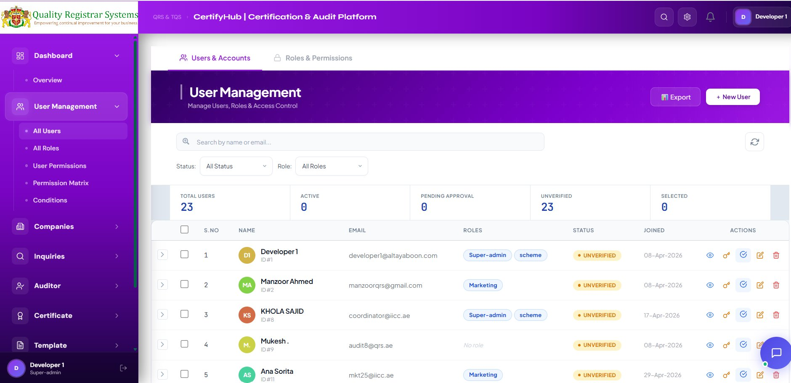
Figure 5.1 — User Management screen with the Users & Accounts and Roles & Permissions tabs.

Sub-pages within User Management
Sub-page | Purpose
All Users | Complete user directory with status, role, joined date and per-user actions.
All Roles | Define and manage roles (Auditor, Marketing, Super-admin, etc.).
User Permissions | Grant or revoke specific actions to individual users, overriding role defaults.
Permission Matrix | Grid view of every role × every action — the fastest security review.
Conditions | Define conditional rules (e.g. an Auditor can edit only audits assigned to them).

Action Icons (Per-User Row)
Icon | Action
👁 Eye | View full profile — name, email, role, audit history.
🔑 Key | Open Role & Permission editor for this user.
✅ Tick | Verify (approve) a Pending / Unverified account.
✏ Pencil | Edit basic profile fields (name, phone, role).
🗑 Bin | Soft-delete the user (account hidden, audit trail preserved).

Status Values
- Active — fully verified and operational.
- Pending Approval — email confirmed via OTP, awaiting admin verification.
- Unverified — registered but email not yet confirmed.
- Disabled — administratively disabled (cannot log in, history retained).
✓ Review the Unverified queue at least once per business day. Stale unverified accounts older than 14 days should be deleted to keep the directory clean.

6. Module — Companies (Client)

The Companies (Client) module is the master directory of every client organisation that the Platform audits or has audited in the past. Every audit, inquiry, job and certificate in the platform is linked back to a Company record.

Primary Users
Role | What They Do Here
Marketing | Add new client companies, update contact details.
Scheme Coordinator | Verify company information before audits are scheduled.
Auditor | Read-only access — view client details before performing an audit.
Super-admin | Full control: add, edit, delete, bulk import and export.

6.1 Companies List View
Click Companies → All Companies in the sidebar. The screen shows the running record count (e.g. Showing 1–10 of 7,547 companies), the search bar, the filter row, two top-bar action buttons (Reports and Analytics), and the table of companies itself.
📊 Reports Button — Every Companies module list view has a green Reports button on the top-right. Apply any filters first (date range, month, status, group, standard, etc.) and then click Reports — the platform generates a styled PDF / Excel of exactly the rows currently visible. The same applies on every list view in the platform — Companies, Inquiries, Certificates, Job Registrar, Standards, Countries — so you always get a report that matches what you see on screen.

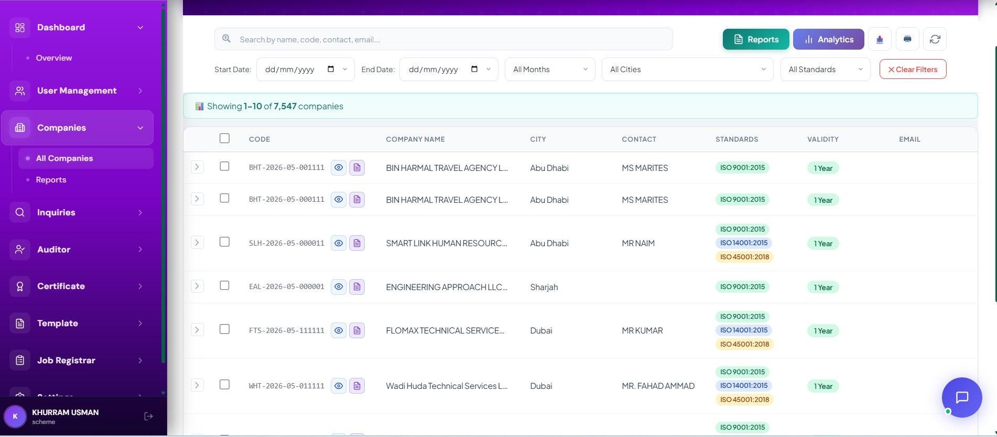
Figure 6.1 — Companies module list view.

Search Bar
The search bar accepts any of: company name, company code, contact person, or email address. Searching is live — results filter as you type.

Filter Row
Filter | What It Does
Start Date / End Date | Show companies registered between these dates.
All Months | Quick filter by calendar month.
All Cities | Limit to one city (Dubai, Abu Dhabi, Sharjah …).
All Standards | Show only companies certified against a specific ISO.
Clear Filters | Red button — resets every filter at once.

List Columns
Column | Description | Example
Code | Auto-generated unique code. Format: XXX-YYYY-MM-NNNNNN. | BHT-2026-05-001111
Company Name | Registered name of the organisation. | BIN HARMAL TRAVEL AGENCY L…
City | Primary city. | Abu Dhabi
Contact | Primary contact person. | MS MARITES
Standards | ISO standards (colour-tagged). | ISO 9001:2015, ISO 14001:2015
Validity | Certificate validity period. | 1 Year
Email | Primary contact email. | contact@bht.ae

6.2 Adding a New Company — Step by Step
Click + Add Company. A green-themed modal titled New Company — Register a new company for ISO certification opens. The form has four sections: Company Information, Location, Contact Details and ISO Standards.
Section A • Company Information
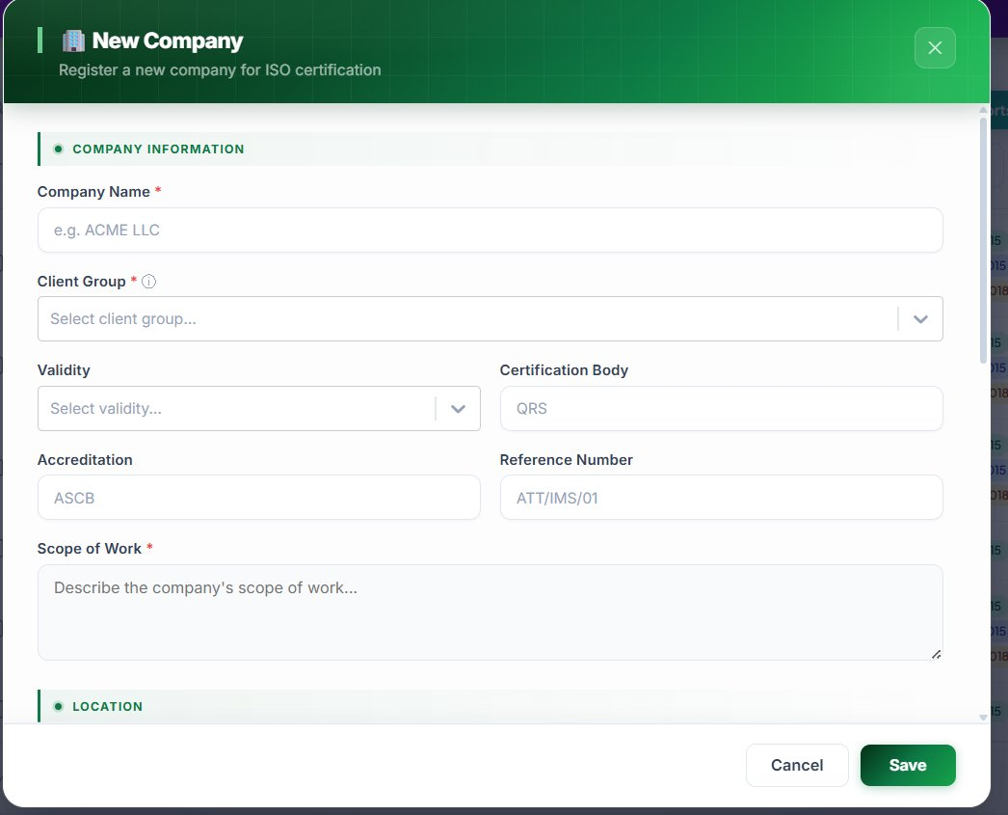
Figure 6.2 — New Company form (top): Company Information section.
Step 1 ▸ Enter the Company Name
Type the legal name of the organisation. Example: ACME LLC. This field is mandatory (red asterisk).
Step 2 ▸ Select the Client Group
Open the Client Group dropdown and choose the group this client belongs to. Mandatory.
Step 3 ▸ Choose the Validity
Pick the certificate validity period — typically 1 Year, 2 Years or 3 Years.
Step 4 ▸ Enter the Certification Body
Default is QRS (Quality Registrar Systems). Change only if the client is certified by a different body.
Step 5 ▸ Enter the Accreditation
Type the accreditation body code, e.g. ASCB, EIAC, UKAS.
Step 6 ▸ Enter the Reference Number
Internal reference, format <DEPT>/<TYPE>/<NN> — e.g. ATT/IMS/01.
Step 7 ▸ Describe the Scope of Work
Type a clear paragraph describing the activities the certificate will cover. This text is printed verbatim on the certificate — write it carefully. Mandatory.

Section B • Location
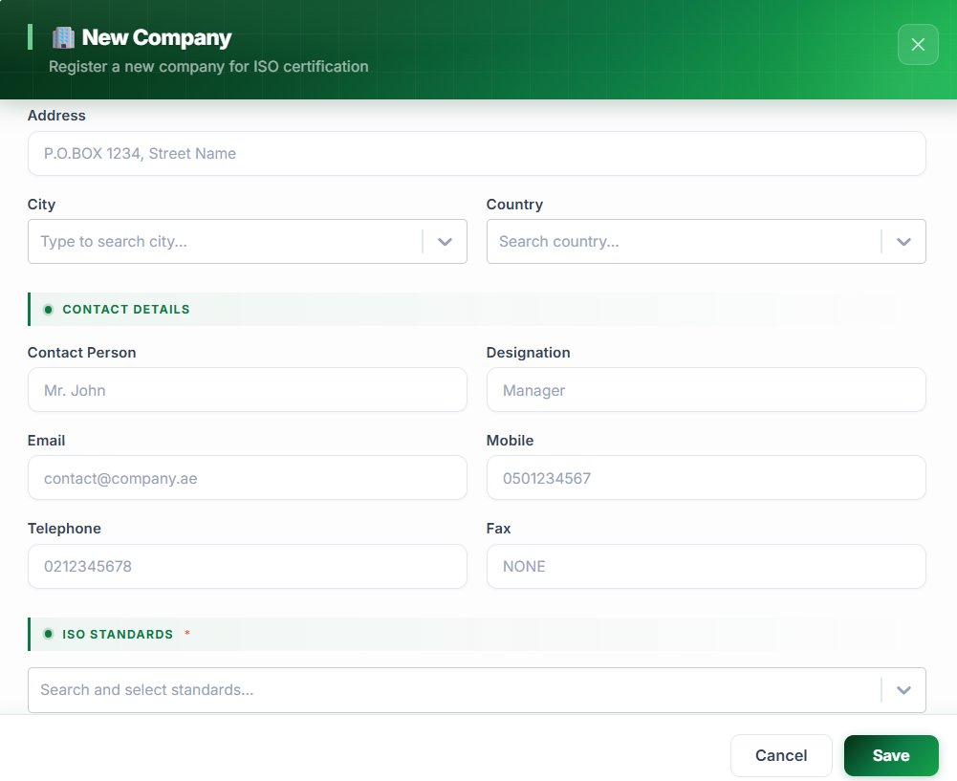
Figure 6.3 — New Company form: Location, Contact Details, ISO Standards.
Step 8 ▸ Enter the Address
Full street address (e.g. P.O. BOX 1234, Street Name). Printed on the certificate.
Step 9 ▸ Select the City
Type to search — only valid cities from the Cities master appear.
Step 10 ▸ Select the Country
Type to search the country list. The flag icon appears once selected.
Section C • Contact Details
Step 11 ▸ Enter the Primary Contact Person
Full name, e.g. Mr. John. This person becomes the default recipient of all platform emails.
Step 12 ▸ Enter the Designation
Job title — e.g. Manager, QHSE Manager, General Manager.
Step 13 ▸ Enter Email, Mobile, Telephone, Fax
Email is critical — all outbound platform communication goes there. If the company has no fax, type NONE so the certificate doesn't show a blank field.
Section D • ISO Standards
Step 14 ▸ Search & Select Standards
Click the Search and select standards… field, type (e.g. *9001*) and tick each standard. Multiple standards can be selected (integrated management systems). Mandatory — at least one required.
Step 15 ▸ Save
Click the green Save button at the bottom-right. The system validates every mandatory field, auto-generates the Company Code (e.g. BHT-2026-05-001111) and adds the company to the directory.
⚠ Mandatory fields: Company Name, Client Group, Scope of Work, at least one ISO Standard. Other fields are optional but strongly recommended — incomplete records cause certificate-printing errors later.

6.3 Reports — Filtered Report Generation
The Companies module's Reports button (green, top-right) produces a styled PDF or Excel of the company directory, filtered exactly the way you see it on screen. This is the single place to answer questions like "how many new clients did we onboard in May?", "which Abu Dhabi clients hold ISO 45001?", or "give me every company under QRS group registered this quarter". Marketing typically runs it monthly to track onboarding; Super-admins run it at year-end for the management deck.

Step-by-Step — Generating a Companies Report
Step 1 ▸ Apply the filters you need
Pick any combination of Start Date / End Date, All Months (single calendar month), All Cities, All Standards. The list updates live — what you see is what gets exported.
Step 2 ▸ Confirm the count
The header chip — Showing 1–10 of 7,547 companies — updates as you filter. Always glance at it before exporting so you don't ship the whole 7,547 by accident.
Step 3 ▸ Click the green Reports button (top-right)
A small picker appears with two options: PDF (styled report) and Excel (raw .xlsx).
Step 4 ▸ Pick the format
PDF is for sharing with management or the client (carries the QRS letterhead and the filter summary at the top). Excel is for further analysis — sorting, pivoting, charting.
Step 5 ▸ Save / Send
The file downloads with the name format CompaniesReport_<YYYY-MM-DD>_<filters>.pdf — e.g. CompaniesReport_2026-05-14_Abu-Dhabi_ISO9001.pdf. Attach to email or upload to the Job Registrar Documents tab.

What's Inside the Companies Report
Section | Contents
Cover | QRS branding · Report title · Date generated · The filters that produced the report (e.g. "City: Abu Dhabi · Standard: ISO 9001:2015 · From 01-Apr-2026 to 30-Apr-2026").
Summary block | Total count · Count by Standard · Count by City · Count by Client Group (QRS / TQS).
Detail table | Every company in scope with: Code, Name, City, Country, Contact, Designation, Email, Standards (tags), Validity, Registered date.
Footer | Page X of Y · QRS contact line · Confidentiality notice.

Use Cases by Role
Role | Typical Filter Combination | What They Use the Report For
Marketing | Start Date / End Date covering this month. | Monthly onboarding report — count of new clients added, broken down by standard. Sent to the marketing head.
Scheme Dept. | All Standards = ISO 45001:2018 (or whichever standard). | Pool of certified companies under a single scheme — used when planning the surveillance cycle.
Super-admin | Empty filters (or by year). | Year-end management report covering the full client base.
Auditor | City = own region; Standards = own qualifications. | Pre-visit briefing pack — every client in the auditor's region certified for a standard they cover.

✓ Best practice — Always apply Start / End Date filters when running a Companies report. An unfiltered export pulls the entire history (7,000+ rows) and is rarely useful. Two clicks of filtering before export saves the recipient 20 minutes of reading.

7. Module — Inquiries (Proceeding)

The Inquiries module — internally called the Proceeding Module — is the bridge between sales and operations. Every certification engagement starts as an inquiry. The header reads: “Manage Certification Inquiries — Marketing submits, Scheme reviews & issues.”

Two-Step Workflow
Step | Department | Action
1. Submit | Marketing | Receives a request → creates an inquiry → submits.
2. Review & Issue | Scheme Dept. | Reviews → verifies scope → schedules audit or issues document.

Inquiry Types
Type | When to Use
Surveillance | Annual check-up of an existing certified client.
Re-Certification | End of the 3-year cycle — full re-audit required.
New Client | A brand-new prospect being onboarded.

7.1 Inquiries List View
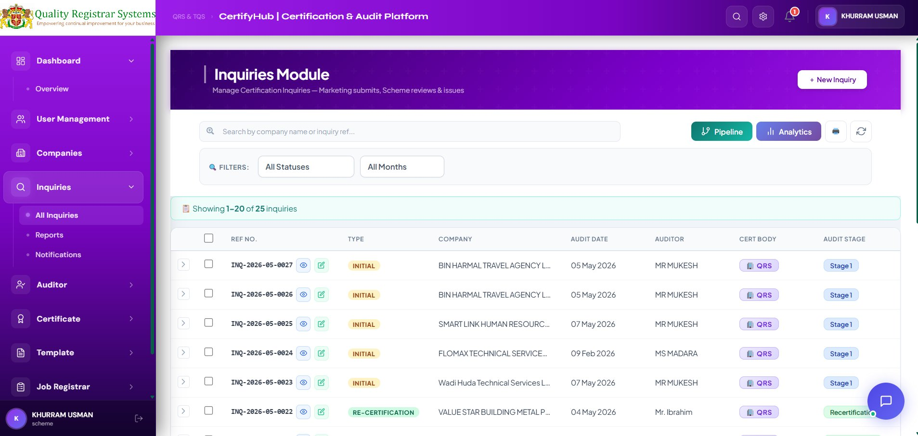
Figure 7.1 — Inquiries module list view with Pipeline and Analytics toggles.
📊 Reports Button — Every Inquiries module list view has a green Reports button on the top-right. Apply any filters first (date range, month, status, group, standard, etc.) and then click Reports — the platform generates a styled PDF / Excel of exactly the rows currently visible. The same applies on every list view in the platform — Companies, Inquiries, Certificates, Job Registrar, Standards, Countries — so you always get a report that matches what you see on screen.

List Columns
Column | Description | Example
Ref No. | Format: INQ-YYYY-MM-NNNN. | INQ-2026-05-0027
Type | Inquiry type — colour-tagged. | INITIAL / RE-CERTIFICATION
Company | Client organisation. | BIN HARMAL TRAVEL AGENCY L…
Audit Date | Planned audit date. | 05 May 2026
Auditor | Suggested auditor (final assignment by Scheme). | MR MUKESH
Cert Body | Certification body (QRS or TQS). | QRS
Audit Stage | Stage 1 / Stage 2 / Surveillance / Recertification. | Stage 1

7.2 Submitting a New Inquiry — Step by Step
Click + New Inquiry. A blue-themed modal titled Submit Certification Inquiry opens.
Section A • Inquiry Type & Group
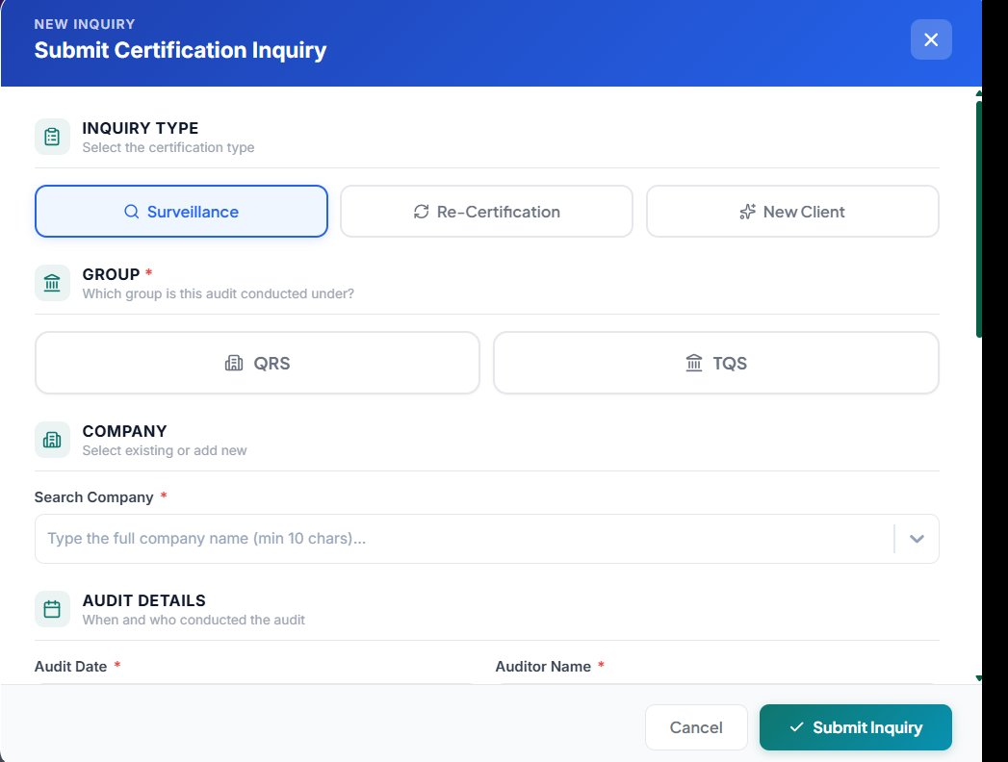
Figure 7.2 — Submit Certification Inquiry form: Inquiry Type, Group, Company, Audit Details.
Step 1 ▸ Choose the Inquiry Type
Click Surveillance, Re-Certification or New Client. The selected card highlights in blue.
Step 2 ▸ Choose the Group
Pick QRS or TQS. Mandatory.
Section B • Company & Audit Details
Step 3 ▸ Search & Select the Company
Type the company name (minimum 10 characters to trigger the auto-complete). If the company does not exist, save & close, add it in Module 6, then return.
Step 4 ▸ Set the Audit Date
Click Audit Date and pick the planned date (dd/mm/yyyy).
Step 5 ▸ Enter the Auditor Name
Type the suggested auditor's name (e.g. MR. HASSAN AL MALIK).

Section C • Audit Stage & References
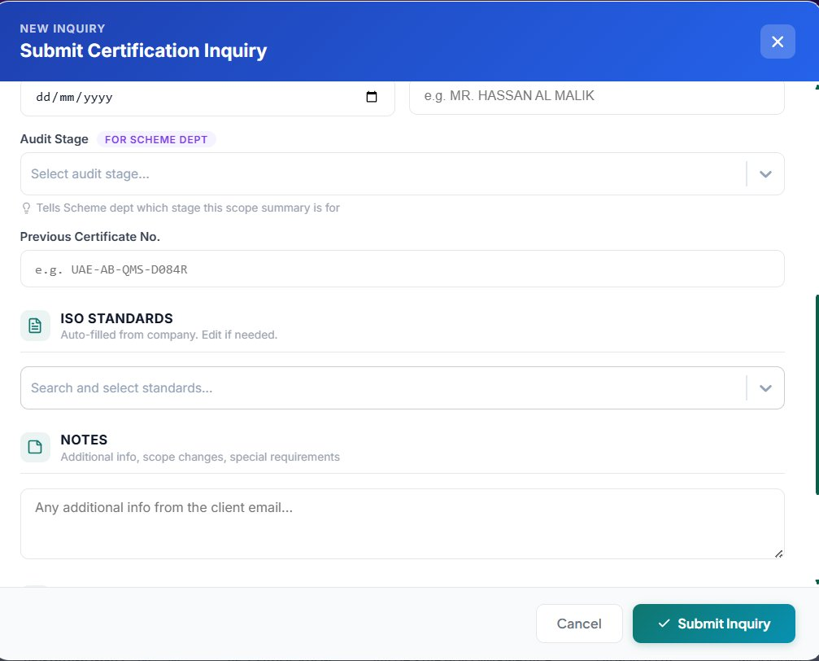
Figure 7.3 — Submit Certification Inquiry form: Audit Stage, Previous Certificate, ISO Standards, Notes.
Step 6 ▸ Select the Audit Stage
Open the Audit Stage dropdown and choose Stage 1 / Stage 2 / Surveillance / Recertification. The purple FOR SCHEME DEPT tag confirms this field is critical for downstream processing.
Step 7 ▸ Enter Previous Certificate No. (if applicable)
For Re-Certification / Surveillance, paste the existing certificate number (e.g. UAE-AB-QMS-D084R). Leave blank for New Client.
Section D • ISO Standards & Notes
Step 8 ▸ Confirm ISO Standards
Auto-filled from the company record. Edit only if scope has genuinely changed.
Step 9 ▸ Add Notes (optional but recommended)
Use the Notes text area for scope changes, special requirements, language preferences, etc.
Step 10 ▸ Submit
Click the green ✓ Submit Inquiry button. The system auto-generates the Ref No., sets status to Submitted, and notifies the Scheme department.

7.3 Inquiry Lifecycle
Status | Owner | What Happens
Submitted | Scheme Dept. | Inquiry appears in the Scheme inbox for review.
Under Review | Scheme Dept. | Scheme verifies scope, standards, validity, audit date.
Approved | Scheme Dept. | Approved → Audit Compliance record auto-created.
Scheduled | Audit Compliance | Audit scheduled, Job auto-created in Job Registrar.
Closed | Audit Compliance | Audit completed and certificate issued.
Rejected | Scheme Dept. | Rejected with reason — sent back to Marketing.

7.4 Reports — Filtered Report Generation
The Inquiries (Proceeding) module's Reports button generates a styled report of the proceeding pipeline — the inquiries that came in, who owns them, what stage they're at, and what's stuck. Marketing runs this report every month to show the inquiry volume and conversion rate; the Scheme Department uses it to see how many inquiries are sitting in their queue and how old each one is.

Step-by-Step — Generating an Inquiries Report
Step 1 ▸ Filter by date range
Set Start Date and End Date for the period you care about — typically the calendar month for Marketing's monthly report, or a quarter for management reviews.
Step 2 ▸ Filter by type and status
Pick Inquiry Type (Surveillance / Re-Certification / New Client) and Status (Submitted / Under Review / Approved / Scheduled / Closed / Rejected). Combine to answer specific questions — e.g. "all New Client inquiries Under Review in May".
Step 3 ▸ Click Reports → pick PDF or Excel
PDF for sharing in management meetings; Excel when you need to pivot by salesperson / standard / region.
Step 4 ▸ Save / Send
File name pattern: InquiriesReport_<YYYY-MM-DD>_<filters>.pdf.

What's Inside the Inquiries Report
Section | Contents
Cover | Report title · Date · Filter summary · Generated by (user name and role).
Pipeline summary | Count by status (Submitted / Under Review / Approved / Scheduled / Closed / Rejected) · Conversion rate (% Approved / Total submitted).
By type | Count by Inquiry Type — New Client / Surveillance / Re-Certification.
Detail table | Ref No · Type · Company · Audit Date · Auditor · Cert Body · Audit Stage · Status · Submitted By · Submitted On · Days in Current Status.
Aging block | Inquiries older than 7 / 14 / 30 days still Under Review — surfaces bottlenecks in the Scheme queue.
Footer | Page X of Y · QRS contact · Confidentiality.

Use Cases by Role
Role | Typical Filter Combination | What They Use the Report For
Marketing | This month's Start–End dates. | Monthly proceeding report — number of inquiries submitted, conversion %. Sent to the marketing head and management.
Scheme Dept. | Status = Submitted OR Under Review. | Daily / weekly worklist — what's pending in my queue, sorted by age.
Coordinator | Status = Approved · Inquiry Type = New Client. | Pipeline of audits coming up that need scheduling.
Super-admin | Whole year. | Annual sales / proceeding KPI — total inquiries, conversion %, lead-to-cert time.

ℹ Bottleneck spotting — The aging block in the report highlights inquiries that have been Under Review for more than 14 days. Use it in the weekly Scheme stand-up to clear stale items. A healthy queue keeps every inquiry under 7 days; anything over 14 days is a quality signal worth investigating.

9. Module — Audit Compliance

Audit Compliance is the heart of the Platform. Every company that needs to be audited has one or more compliance records here, each tracking a single audit cycle. The module is shaped around the Audit Management workflow: pick a company → schedule the audit → run the stages → close out.
This module is owned by the Scheme Department and is primarily used to generate the audit pack documents for Stage 1 and Stage 2 — audit plans, checklists, reports, recommendations and certificates — produced from the Templates library in one click. The real-world scheduling of audits (picking dates, assigning lead auditors per visit, sending notifications, handling reschedules and cancellations) is handled by the Coordinator in the Audit Schedule module (see Section 9A).
ℹ Two-module split — Module 9 (Audit Management / Compliance) is the Scheme Department's document-generation engine for the Stage 1 and Stage 2 audit packs. Module 9A (Audit Schedule, currently in development) is the Coordinator's real-time scheduling tool. The two modules hand off cleanly: the Coordinator schedules the visit, the Scheme Dept. produces the paperwork.

9.1 Audit Management — List View
The list view shows every audit currently tracked in the platform with rich filters and the option to export the entire filtered set to PDF or Excel.
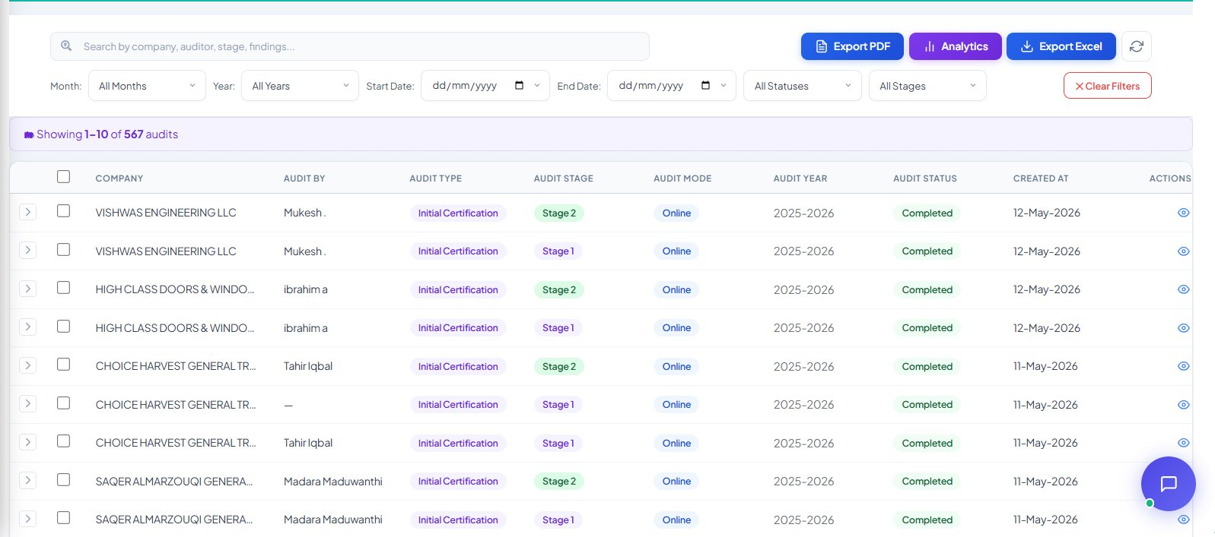
Figure 9.1 — Audit Management list view, showing 567 audits with filters and export buttons.

Search & Filters
Filter | What It Does
Search | Search by company name, auditor name, audit stage or findings.
Month | Quick filter by calendar month.
Year | Filter by audit year (e.g. 2025–2026).
Start / End Date | Date range filter.
All Statuses | Scheduled / In Progress / Completed / Non-Compliant.
All Stages | Stage 1 / Stage 2 / Surveillance / Recertification.
Clear Filters | Red button — resets every filter.

Top-Bar Action Buttons
Button | Purpose
Export PDF (blue) | Downloads the currently filtered audit list as a styled PDF report.
Analytics (purple) | Opens dashboards: audits by stage, by auditor, by status, monthly trend.
Export Excel (blue) | Downloads the filtered list as an .xlsx file for offline analysis.
Refresh icon | Reloads audits from the server.

List Columns
Column | Description
Company | Client organisation being audited.
Audit By | Lead auditor assigned to this audit.
Audit Type | Initial Certification / Surveillance / Re-Certification.
Audit Stage | Stage 1 or Stage 2 (colour tag).
Audit Mode | Online / On-site / Hybrid.
Audit Year | Year covered by this audit (e.g. 2025–2026).
Audit Status | Scheduled / In Progress / Completed / Non-Compliant.
Created At | Date the audit record was created.
Actions | Eye icon — open the Audit Management modal.

9.2 Audit Management Modal — Three Tabs
Clicking the eye icon (or scheduling a new audit from a Company record) opens the Audit Management modal. The modal has three tabs that you complete in order: Company Info → Schedule Audit → Audit Stages.
Tab 1 • Company Info
Confirms which client the audit is for and shows their key information. If you arrived from the Company record, the company is pre-selected; if not, choose it from the dropdown.
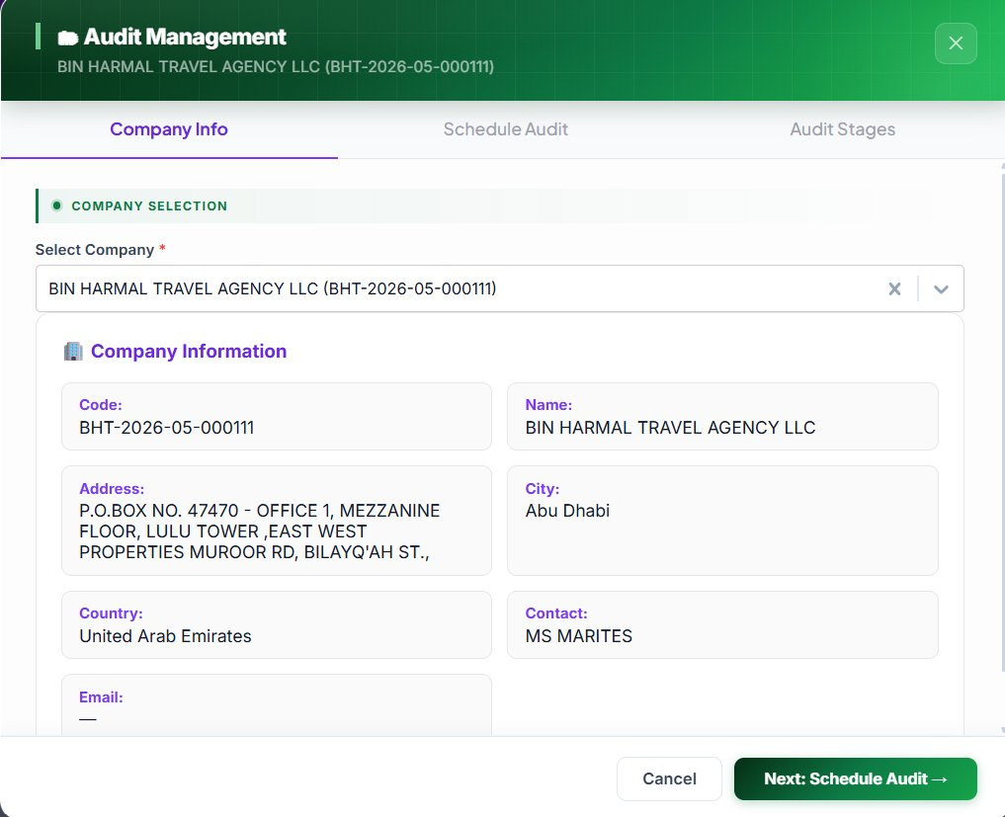
Figure 9.2 — Audit Management modal, Tab 1: Company Info.
Step 1 ▸ Select the Company
Open Select Company dropdown — type to search. The list is limited to active company records. Mandatory field.
Step 2 ▸ Verify Company Information
Read the read-only Company Information block: Code, Name, Address, City, Country, Contact and Email. If anything looks wrong, cancel the modal, fix the company in Module 6, then come back.
Step 3 ▸ Move to next tab
Click the green Next: Schedule Audit → button at the bottom-right.
ℹ If the company has an incomplete record (e.g. missing email or no ISO Standards), the system warns you here and blocks progress until the record is fixed.

Tab 2 • Schedule Audit
The Schedule Audit tab is where the audit's identity is defined — type, standards, validity, mode, current stage and status. Every field here drives downstream document generation and certificate issuance.
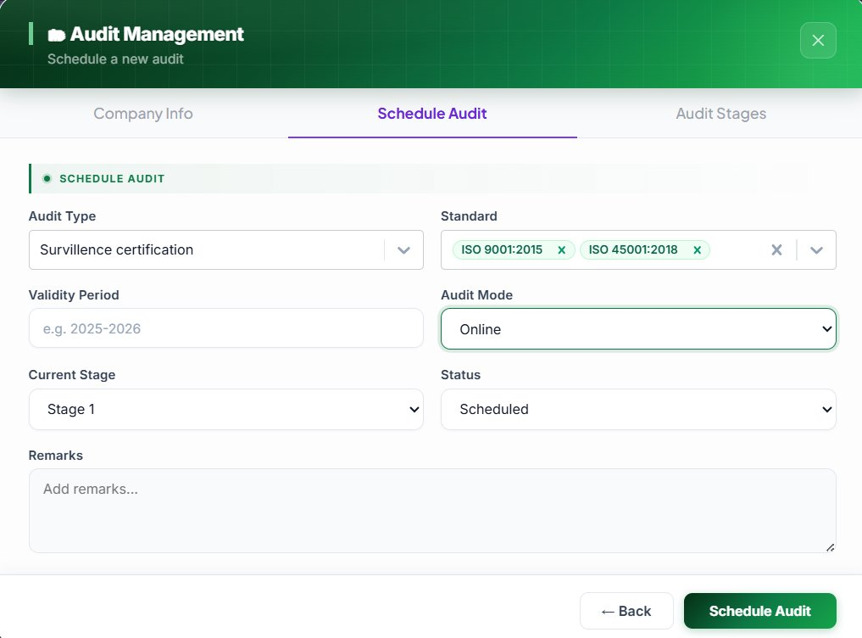
Figure 9.3 — Audit Management modal, Tab 2: Schedule Audit.
Step 4 ▸ Select the Audit Type
Open the Audit Type dropdown. Options: Initial Certification, Surveillance Certification, Re-Certification, Transfer Audit. This drives which template set is loaded for Stage 1 and Stage 2.
Step 5 ▸ Pick the Standard(s)
Open the Standard multi-select. The list is pre-filtered to standards the company is registered for. Selected standards appear as removable green tags (e.g. ISO 9001:2015 ✕, ISO 45001:2018 ✕). Multiple standards = integrated management system audit.
Step 6 ▸ Enter the Validity Period
Type the certificate validity window in the format YYYY–YYYY (e.g. 2025–2026). Used to compute the certificate's issue and expiry dates.
Step 7 ▸ Select the Audit Mode
Open Audit Mode. Options: Online, On-site, Hybrid. Online audits skip the on-site travel logistics and use video conferencing only.
Step 8 ▸ Set the Current Stage
Open Current Stage. Pick Stage 1 for a brand-new audit. After Stage 1 is closed you'll come back here and change it to Stage 2.
Step 9 ▸ Set the Status
Open Status. Typical lifecycle: Scheduled → In Progress → Completed. If findings make the audit non-compliant, pick Non-Compliant — this blocks certificate issuance until resolved.
Step 10 ▸ Add Remarks
Use the Remarks text area for any extra context (e.g. client requested specific dates, scope clarifications, auditor notes). Visible to anyone with access to this audit.
Step 11 ▸ Save & continue
Click the green Schedule Audit button. Use ← Back if you need to fix the Company Info tab.

Tab 3 • Audit Stages
The Audit Stages tab is where you record the operational detail for each stage — date, lead auditor, technical expert, ANZIC code, and remarks. You add one Stage entry per audit visit; a normal certification cycle has two Stage entries (Stage 1 and Stage 2), surveillance has one.

Fields on Each Stage Entry
Field | Description
Select Audit | Links the stage to the audit just created in Tab 2.
Stage Name | Stage 1, Stage 2, Surveillance, Recertification.
Audit Date | Actual date of this stage's audit visit.
Audit By | Lead auditor (must be Active and qualified for the selected standards).
Technical Expert | Optional secondary auditor or technical expert.
ANZIC Code | Industry classification code for this audit.
Remarks | Free-text notes specific to this stage.

Workflow Summary
- Open the Audit Stages tab → click Add Audit Stage.
- Fill all fields → click Save Stage.
- Repeat for Stage 2 when you return after Stage 1 closure.
- Job Registrar (Module 13) auto-creates a Job linked to this audit.
- Audit documents (Stage 1 / Stage 2 templates) are produced from Module 12.
- When Stage 2 is closed and all NCRs are resolved, the Generate Certificate action becomes available (Module 14).
⚠ Stage 2 cannot start until Stage 1 = Completed and all Stage 1 NCRs are closed. Certificate issuance is blocked if any open NCR is attached to the company.

9.3 Single-Click Document Generation by the Scheme Department
Audit Management is the engine that prepares all audit documents for the Job Registrar. Documents are produced based on each audit when it is completed — and they are generated by the Scheme Department in a single click, without any manual copy-paste from Word.

How it Works
- After the auditor marks the stage as Completed in the Audit Stages tab, the audit appears in the Scheme Department's queue.
- The Scheme user opens the audit record and clicks Generate Document (or Generate Stage 1 Pack / Generate Stage 2 Pack).
- The platform reads the audit metadata (company, standards, auditor, dates, scope, NCRs) and merges it into the selected template from the Templates module (Module 12).
- Within a minute or two, the complete document set (audit plan, checklist, report, recommendation, etc.) is generated, watermarked, and attached to the Job Registrar entry — see Module 13.
- All files appear under the company's Audit Documents tab, ready for review, e-signing and delivery to the client.
ℹ Audit Management documents are prepared by the Scheme Department, primarily for the initial audit cycle (Stage 1 → Stage 2). Surveillance and Re-certification cycles reuse the same engine but with their dedicated template sets.

Why This Matters
Before (manual) | After (single-click)
Open Word, copy company details from Companies module. | Platform reads company data automatically.
Manually paste auditor, dates, scope into each document. | Audit Stage fields merge into placeholders.
Save 8–10 files per audit, name them, email them. | All files generated, named and stored in one click.
Risk of typos, mismatched standards, wrong dates. | Single source of truth — zero data-entry errors.
~2 hours of preparation per audit. | ~2 minutes per audit pack.

Where the Generated Documents Land — Audit Documents Tab
Once the Scheme Department clicks Generate Document and the platform finishes producing the pack (audit plan, checklist, report, recommendation, etc.), every file is automatically attached to the company's record and visible from the Audit Documents tab inside the company / audit detail view.
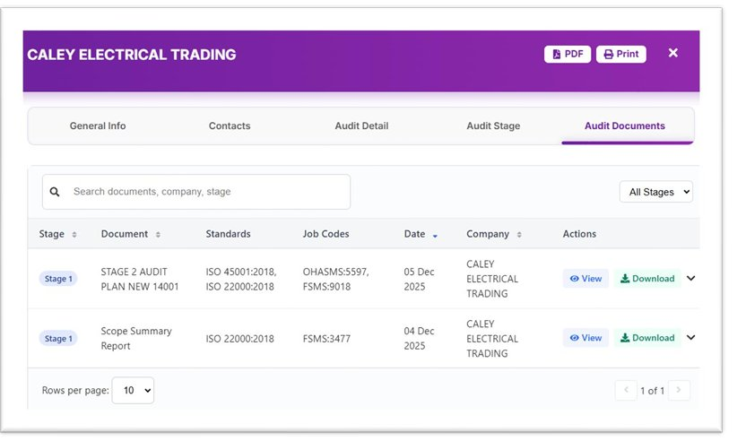
Figure 9.4 — Company audit detail modal with the Audit Documents tab selected (CALEY ELECTRICAL TRADING). The tab strip across the top (General Info · Contacts · Audit Detail · Audit Stage · Audit Documents) gives the Scheme user every angle on the audit; the documents table lists every file the platform has generated for this company — Stage, Document name, Standards covered, Job Codes, Date, Company, and per-row View / Download actions.

Reading the Audit Documents Tab
Column | Description | Example
Stage | Colour tag — Stage 1 / Stage 2 / Surveillance / Recertification. | Stage 1
Document | Internal name of the generated file. | STAGE 2 AUDIT PLAN NEW 14001
Standards | ISO standards the file covers (comma-separated). | ISO 45001:2018, ISO 22000:2018
Job Codes | Job-Registrar codes attached to each standard. | OHASMS:5597, FSMS:9018
Date | Date the document was generated. | 05 Dec 2025
Company | Client organisation — repeats across every row. | CALEY ELECTRICAL TRADING
Actions | View opens the file in-browser; Download saves a copy locally; chevron expands to versions. | View · Download · ▼

Filters & Top-Bar
Use the Search bar ("Search documents, company, stage") to find a specific file inside a large set, and the All Stages dropdown on the right to narrow to Stage 1 / Stage 2 / Surveillance / Recertification. The purple top-bar carries two export actions — PDF (the entire documents list) and Print — plus an X to close the modal. The Rows per page selector at the bottom-left controls list density (10 / 25 / 50).
ℹ Why this tab matters — Anyone with access to the company record (Scheme, Coordinator, Auditor) can pull up the audit pack from here without going back to the Job Registrar. View opens in-browser for a quick check; Download saves a local copy when the auditor needs the file offline for the visit.

9A. Module — Audit Schedule (Coordinator — In Development)

The Audit Schedule module is the Coordinator's workspace for scheduling the real audit visits — picking dates, assigning the lead auditor for each row, choosing on-site / online mode, and sending notifications to Marketing, the Auditor and the Coordinator. It complements Module 9 (Audit Management) which the Scheme Department uses to generate the audit pack documents.
⚠ Development Status — This module is in active development. The screens below are functional today, but a few refinements are still being polished. When the development phase is completed, the Coordinator will schedule real audits for each auditor directly from this module — full handoff from Audit Management (Scheme Dept., document generation) to Audit Schedule (Coordinator, real-time scheduling).

How Module 9 and Module 9A Differ
Aspect | Module 9 — Audit Management | Module 9A — Audit Schedule
Owner | Scheme Department | Coordinator
Primary purpose | Generate audit pack documents (Stage 1 & 2) | Schedule real audits, notify stakeholders
Output | Audit Plan / Checklist / Report / Recommendation PDFs | Calendar entries, notifications, schedule status
Hand-off | Hands documents to the Coordinator | Coordinator picks up and schedules the real visit
Status | Live | In Development

9A.1 Audit Schedule — List View
The Audit Schedule list view shows every schedule the Coordinator has created — past, present and upcoming — with its title, client group, audit-rows count, coordinator name and current status (Published / Cancelled / Draft). Use the Stats button on the top-right for a quick summary.
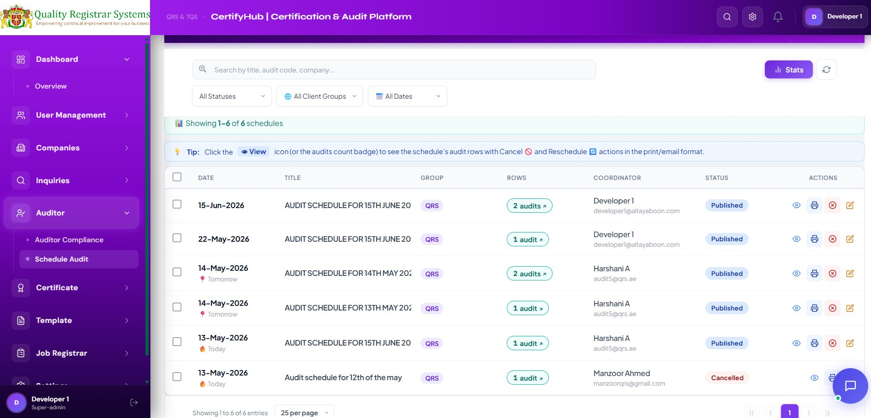
Figure 9A.1 — Audit Schedule list view with Published, Cancelled and Draft entries. Each row carries the View, Print, Cancel and Edit actions.

List Columns
Column | Description | Example
Date | The schedule date. | 15-Jun-2026
Title | Free-text title of the schedule. | AUDIT SCHEDULE FOR 15TH JUNE 2026
Group | Client group — QRS or TQS. | QRS
Rows | Number of audits inside this schedule. | 2 audits
Coordinator | Owner of the schedule. | Developer 1
Status | Schedule lifecycle status. | Published / Cancelled / Draft
Actions | View · Print · Cancel · Edit. | (icons)

Filters & Search
Filter the list by All Statuses, All Client Groups, and All Dates. The Search bar matches against schedule title, audit code and company name in any row inside a schedule.
ℹ Tip — Click the eye (View) icon or the audits-count badge to open the schedule's audit rows in the print/email-ready detail view, where each row's Cancel and Reschedule actions are also available.

9A.2 Creating a New Audit Schedule
Click the + New Audit Schedule button at the top of the list. The modal has two sections — Schedule Details and Audit Rows — and saves as a Draft by default so you can return to it before publishing.
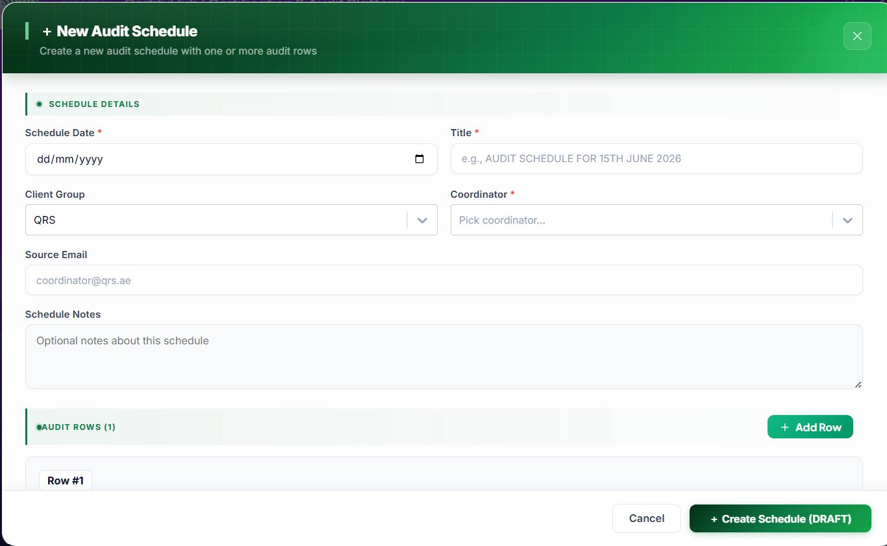
Figure 9A.2 — New Audit Schedule, top half: Schedule Details (date, title, client group, coordinator, source email, notes).
Section A • Schedule Details

Step 1 ▸ Enter the Schedule Date
Click the Schedule Date field and pick the date the schedule is for (dd/mm/yyyy). Mandatory.
Step 2 ▸ Enter the Title
Short, descriptive title — e.g. AUDIT SCHEDULE FOR 15TH JUNE 2026. This is what appears on the printed schedule and in notifications. Mandatory.
Step 3 ▸ Pick the Client Group
Choose QRS or TQS from the dropdown. The list of companies and coordinators is filtered to the chosen group.
Step 4 ▸ Pick the Coordinator
Open the Coordinator dropdown and pick the user who owns this schedule. Mandatory.
Step 5 ▸ Confirm Source Email
Defaults to the coordinator's email (e.g. coordinator@qrs.ae). This is the From: address on outbound schedule notifications.
Step 6 ▸ Add Schedule Notes (optional)
Use the notes area for any context that applies to the whole schedule — public holidays, road closures, special arrangements.
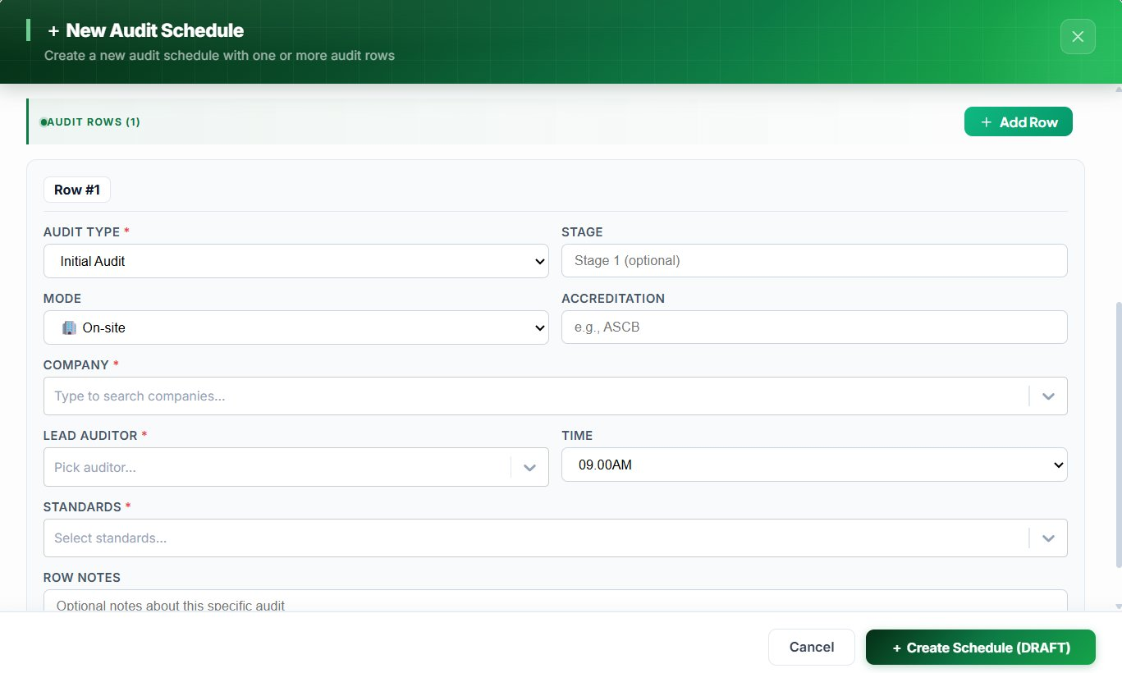
Figure 9A.3 — New Audit Schedule, bottom half: Audit Rows — each row is a separate audit visit with its own type, stage, mode, accreditation, company, lead auditor, time and standards.
Section B • Audit Rows

Each schedule can contain one or more rows — each row is a separate audit visit. Click + Add Row at the top-right of the Audit Rows section to add another. For each row, complete the following:
Step 7 ▸ Pick the Audit Type
Initial Audit / Surveillance Audit / Re-Certification / Transfer Audit. Mandatory.
Step 8 ▸ Set the Stage
Optional. Type Stage 1 / Stage 2 if the row is stage-specific; leave blank for surveillance or transfer visits.
Step 9 ▸ Pick the Mode
On-site / Online / Hybrid. Default On-site.
Step 10 ▸ Enter the Accreditation
Free-text accreditation tag — e.g. ASCB, EIAC, UKAS.
Step 11 ▸ Search & pick the Company
Type to search the master Companies list. Only active companies appear. Mandatory.
Step 12 ▸ Pick the Lead Auditor
Only active auditors qualified for the selected standards appear. Mandatory.
Step 13 ▸ Set the Time
Default 09.00 AM. Adjust per row if multiple audits are in the same schedule on different time slots.
Step 14 ▸ Pick the Standards
Multi-select — ISO 9001, 14001, 22000, 45001, 27001 … Mandatory.
Step 15 ▸ Add Row Notes (optional)
Use the row notes area for special instructions about this specific audit (entry pass, client contact, scope clarifications).
Step 16 ▸ Save as Draft or Publish
Click + Create Schedule (DRAFT) to save without notifying. To publish (and notify Marketing, Auditor, Coordinator), open the saved schedule and click Publish.

9A.3 Reschedule an Audit
If a planned audit can't go ahead on the original date, click the Reschedule icon on the row in the schedule detail view. The Reschedule Audit modal shows the audit metadata read-only at the top and a new schedule section below.
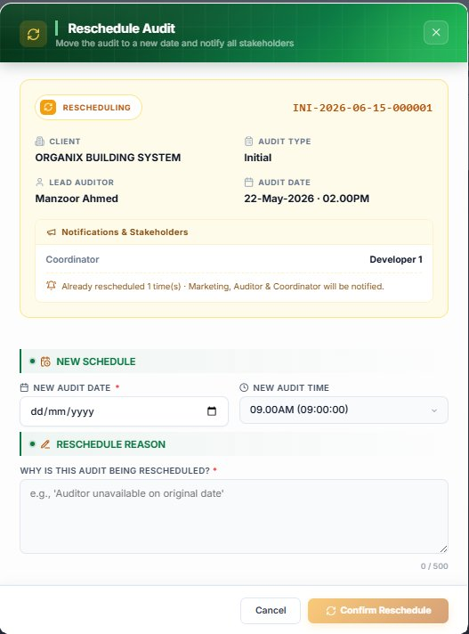
Figure 9A.4 — Reschedule Audit modal: pick the new date, the new time, and explain why the audit is being rescheduled.

Fields
Field | Description
New Audit Date | Pick the new date (dd/mm/yyyy). Mandatory.
New Audit Time | Pick a slot from the time dropdown (default 09.00 AM).
Reschedule Reason | Free-text — explain why (e.g. auditor unavailable, client request, weather, lockdown). Mandatory.

Click Confirm Reschedule to apply. Marketing, Auditor and Coordinator are automatically notified by email. The audit moves to the new date and the previous date is logged in the audit trail. The amber banner "Already rescheduled N time(s)" shows at the top of the modal so the Coordinator can see how many times the audit has been moved — repeated rescheduling is a quality signal worth investigating.

9A.4 Cancel an Audit
Click the red Cancel icon on the row in the schedule detail view to open the Cancel Audit modal. The modal shows the audit metadata at top, four reason cards in the middle, and an explanation box at the bottom.
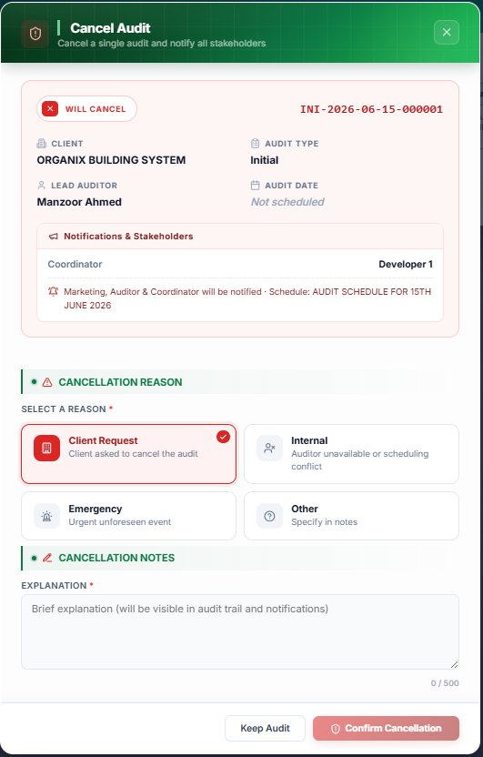
Figure 9A.5 — Cancel Audit modal: pick one of the four cancellation reasons and add a brief explanation. Marketing, Auditor and Coordinator are notified.

Cancellation Reasons
Reason | When to Use
Client Request | Client asked to cancel the audit (re-scoping, budget, withdrawal).
Internal | Auditor unavailable or scheduling conflict on our side.
Emergency | Urgent unforeseen event — illness, natural disaster, force majeure.
Other | None of the above — explain in the notes field.

Step-by-Step
Step 1 ▸ Pick a reason card
Tap one of the four cards (Client Request, Internal, Emergency, Other). The selected card highlights in red.
Step 2 ▸ Type the Explanation
Brief explanation (max 500 chars) — visible in the audit trail and in the notification sent to Marketing, Auditor and Coordinator. Mandatory.
Step 3 ▸ Confirm or Keep
Click Confirm Cancellation to cancel, or Keep Audit to abort. Cancelled audits remain visible in the schedule list with a Cancelled status tag — never deleted. The trail preserves who cancelled, when and why.

9A.5 Audit Schedule Details — Print / Email View
Clicking the eye icon on any schedule row opens the Audit Schedule Details print view. It shows the title (e.g. AUDIT SCHEDULE FOR 14TH MAY 2026) and a tabular breakdown of every audit row inside the schedule — perfect for emailing to the client or printing for the auditor's day-pack.
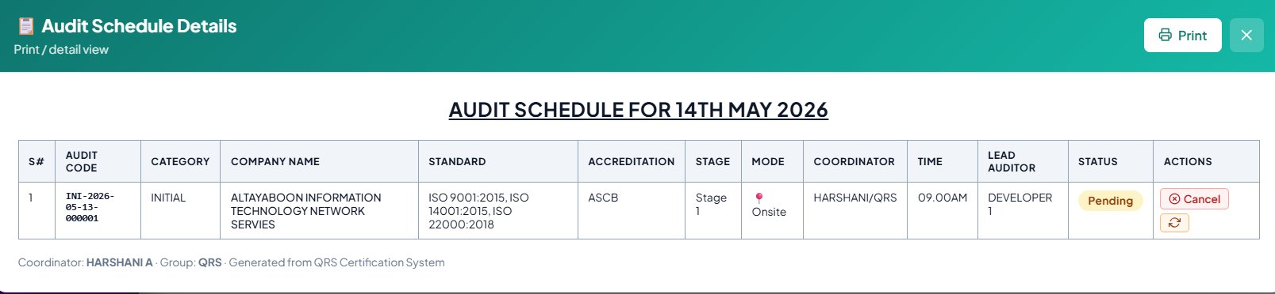
Figure 9A.6 — Audit Schedule Details, print/detail view. The Actions column on this view shows the Cancel and Reschedule icons so the Coordinator can act on a row directly from the detail.

Columns on the Detail View
Column | Description
S# | Sequence number inside the schedule.
Audit Code | Auto-generated audit code (e.g. INI-2026-05-13-000001).
Category | Audit category — Initial / Surveillance / Re-Cert / Transfer.
Company Name | Client organisation being audited.
Standard | Comma-separated list of ISO standards covered.
Accreditation | Accreditation body — ASCB / EIAC / UKAS / …
Stage | Stage 1, Stage 2 (or blank).
Mode | On-site / Online / Hybrid.
Coordinator | Owner of the schedule.
Time | Time slot for the visit (e.g. 09.00 AM).
Lead Auditor | Auditor assigned to this row.
Status | Pending / Completed / Cancelled.
Actions | Cancel · Reschedule (icons).

Click Print to send to the printer, or X to close the view. The detail view is also the entry point for the Cancel and Reschedule actions described in §9A.3 and §9A.4.

9A.6 Status Flow & Notifications
Status | Meaning
Draft | Schedule created but not yet published. Fully editable. No notifications sent.
Published | Schedule is locked and visible to stakeholders. Marketing, Auditor and Coordinator are notified by email.
Cancelled | Schedule cancelled — all rows are marked Cancelled. Reason and explanation are logged in the audit trail.
Pending | Row-level status — the individual audit row hasn't yet been completed by the auditor.
Completed | Row-level status — the audit visit has been completed and the documents are ready in Audit Management.

9A.7 Roadmap — What's Coming Next
Items currently on the development backlog for this module:
• Direct calendar view (week / month) of all schedules, with drag-to-reschedule.
• Auto-suggested lead auditor based on standards, availability and proximity.
• ICS calendar invite attached to every Published notification (so auditors and clients get the event in their own calendar).
• Bi-directional sync with Module 9 (Audit Management) — when a schedule is Published, the Audit Compliance record is auto-created so the Scheme Dept. can start preparing the document pack in parallel.
• Mobile-friendly day-view for auditors arriving on-site (offline-capable).
✓ When the Audit Schedule module is fully released, the end-to-end workflow becomes: Inquiry → Companies → Audit Schedule (Coordinator picks date & auditor) → Audit Management (Scheme generates the pack) → Job Registrar (the day-pack) → Certificate. The Coordinator owns the calendar; the Scheme Dept. owns the paperwork; the Auditor owns the visit.

10. Module — Standards

The Standards module is the master list of every certification standard the Platform supports. Every company, audit, template and certificate references one or more standards from this list — never free-text — which keeps reporting consistent.
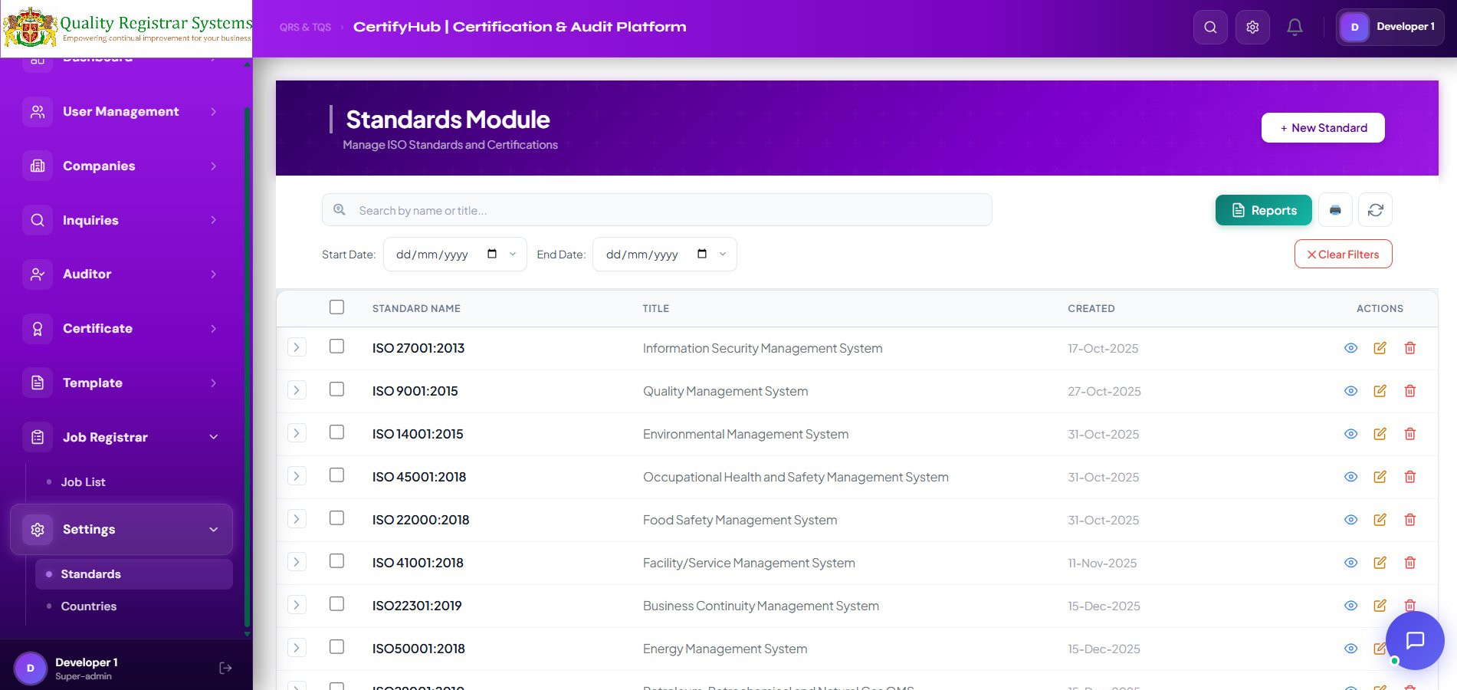
Figure 10.1 — Standards module list view with the +New Standard button.

10.1 List View

Top-Bar
- + New Standard (white button, top-right) — opens the Add Standard modal.
- Search by name or title — live search across both fields.
- Start Date / End Date — filter by the Created date.
- Reports (green) — generate a styled PDF / Excel of the currently filtered list.
- Print / Refresh icons — print the visible page or reload from server.
- Clear Filters (red) — reset all filters.

List Columns
Column | Description | Example
Standard Name | Short code of the standard. | ISO 9001:2015
Title | Full descriptive title. | Quality Management System
Created | Date the standard was added. | 27-Oct-2025
Actions | 👁 View • ✏ Edit • 🗑 Delete. | (icons)

Common Standards Pre-configured
Code | Title
ISO 9001:2015 | Quality Management System
ISO 14001:2015 | Environmental Management System
ISO 45001:2018 | Occupational Health & Safety Management System
ISO 27001:2013 | Information Security Management System
ISO 22000:2018 | Food Safety Management System
ISO 41001:2018 | Facility / Service Management System
ISO 22301:2019 | Business Continuity Management System
ISO 50001:2018 | Energy Management System

10.2 Adding a New Standard — Step by Step
Step 1 ▸ Open the modal
Click the white + New Standard button in the purple banner.
Step 2 ▸ Enter the Standard Name
Short code, e.g. ISO 9001:2015. This is what appears on certificates and dropdowns. Mandatory.
Step 3 ▸ Enter the Title
Full descriptive title, e.g. Quality Management System. Appears on the certificate body.
Step 4 ▸ Add Description (optional)
A short paragraph explaining what the standard covers — useful for auditors and clients.
Step 5 ▸ Set Effective Date
Date the standard became effective (auto-defaults to today).
Step 6 ▸ Save
Click Save. The standard becomes immediately available in every dropdown across the platform (Companies, Inquiries, Audit Compliance, Templates, Certificates).

10.3 Editing or Retiring a Standard
- Locate the standard → click the Edit (pencil) icon.
- Update fields → Save.
- To retire (delete): click the red 🗑 Bin icon → confirm.
⚠ A standard cannot be deleted if it is referenced by any active company, audit or certificate. The platform will block the deletion and show the dependencies.

11. Module — Countries

The Countries module holds the directory of countries where the Platform operates or where its clients are based. Each country is shown with its flag icon, a 2-letter ISO code and the date it was added.
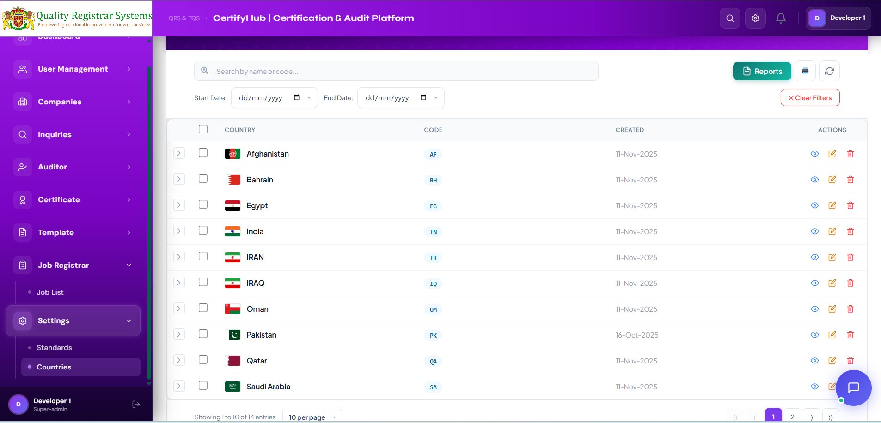
Figure 11.1 — Countries list view. Found under Settings → Countries.

11.1 Where to Find This Module
Countries lives under Settings → Countries in the left sidebar (visible to Super-admins by default). The sibling page Settings → Standards is the Standards module (Section 10).

11.2 List View

Top-Bar
- Search by name or code — type to find a country (e.g. *Pak…* → Pakistan, code PK).
- Start Date / End Date — filter by the Created date.
- Reports (green) — export the filtered list.
- Print / Refresh icons.
- Clear Filters (red).

List Columns
Column | Description | Example
Country | Flag icon + full country name. | 🇦🇪 United Arab Emirates
Code | ISO 2-letter code (blue tag). | AE, PK, IN, OM, BH, SA, QA
Created | Date the country was added to the system. | 11-Nov-2025
Actions | 👁 View • ✏ Edit • 🗑 Delete. | (icons)
Pagination: The footer shows *Showing 1 to 10 of 14 entries* and a page-size selector (10 per page) with arrow controls for moving between pages.

11.3 Adding a New Country — Step by Step
Step 1 ▸ Open the Add Country modal
Click the + Add Country button (top-right of the list).
Step 2 ▸ Enter the Name
Full country name (e.g. United Arab Emirates). Mandatory.
Step 3 ▸ Enter the Code
ISO 3166 alpha-2 code (e.g. AE, PK, IN). The code appears on the company list, in certificates and in reports. Mandatory.
Step 4 ▸ Upload the Flag Icon
Upload a flag PNG or SVG, ≤ 50 KB. The icon shows next to the country name in every dropdown across the platform.
Step 5 ▸ Set Region / Continent (optional)
Useful for regional reporting (e.g. GCC, MENA, Asia, Europe).
Step 6 ▸ Save
Click Save. The country becomes selectable on every form (Companies, Auditor, Certificates).

11.4 Editing or Deleting a Country
- Locate the country → click the orange ✏ Edit icon.
- Update fields → Save.
- To delete: click the red 🗑 Bin → confirm.
⚠ A country cannot be deleted if any active company, auditor or certificate references it. Resolve the dependencies first or mark the country Inactive instead.

12. Module — Templates (Stage 1 & 2)

The Templates module is the library of every audit document the platform can produce — audit plans, checklists, client sheets, scope summaries, recommendations, meeting minutes, certificates. Templates are organised by Stage (Stage 1 or Stage 2) and by Type (DOCUMENT or CERTIFICATE).

12.1 List View (Stage 1)
Open Templates → Templates. By default the list shows all templates; use the Stage filter to narrow down. The screenshot below shows the list filtered to Stage 1 — 35 templates out of 49 total.
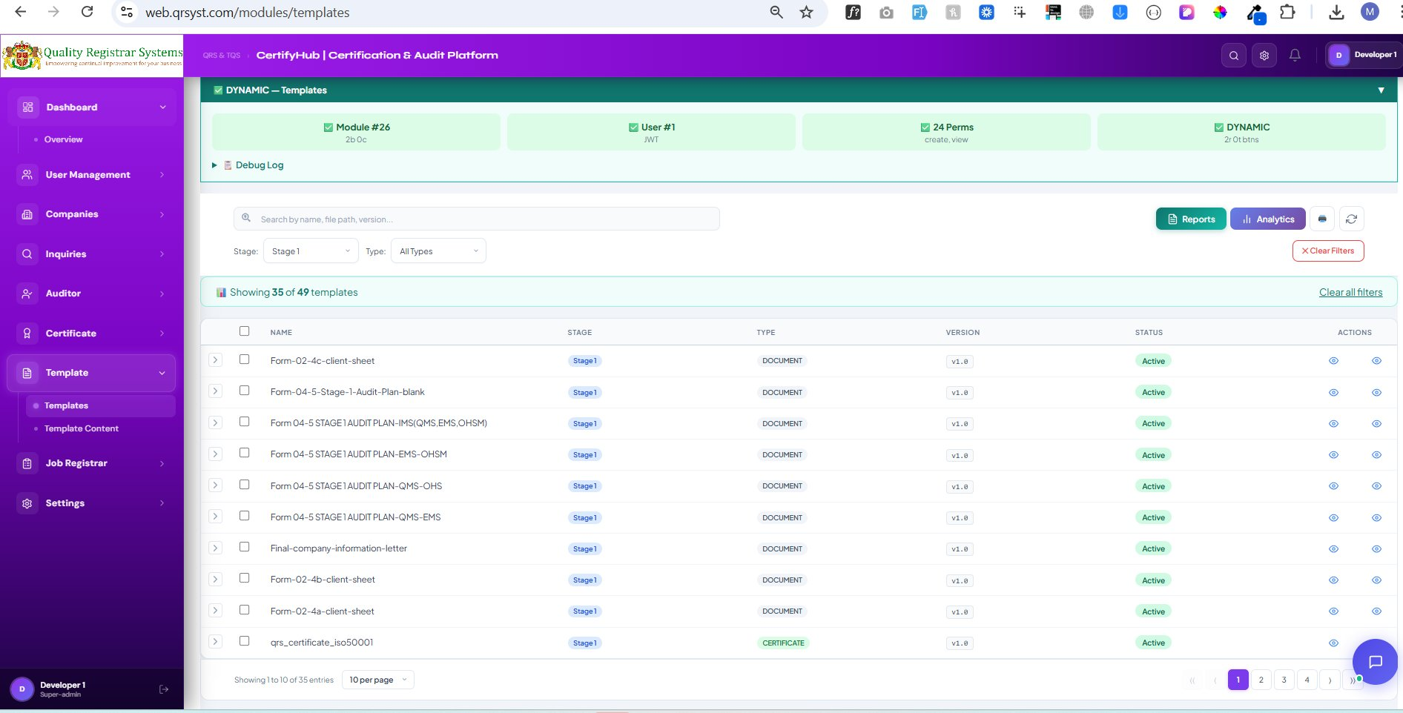
Figure 12.1 — Templates list filtered by Stage 1, showing 35 of 49 templates.

Stage 1 Templates You'll See
- Form 02-4a / 4b / 4c-client-sheet — client information sheets.
- Form 04-5-Stage-1-Audit-Plan-blank — generic Stage 1 audit plan.
- Form 04-5 STAGE 1 AUDIT PLAN-IMS(QMS,EMS,OHSM) — integrated management system Stage 1 plan.
- Form 04-5 STAGE 1 AUDIT PLAN-EMS-OHSM — combined EMS + OHSM Stage 1 plan.
- Form 04-5 STAGE 1 AUDIT PLAN-QMS-OHS — QMS + OHS Stage 1 plan.
- Final-company-information-letter — letter sent to the client after Stage 1.
- qrs_certificate_iso50001 — certificate template (Type = CERTIFICATE).

12.2 List View (Stage 2)
Switching the Stage filter to Stage 2 shows the 14 templates used for the on-site implementation audit and certification recommendation.
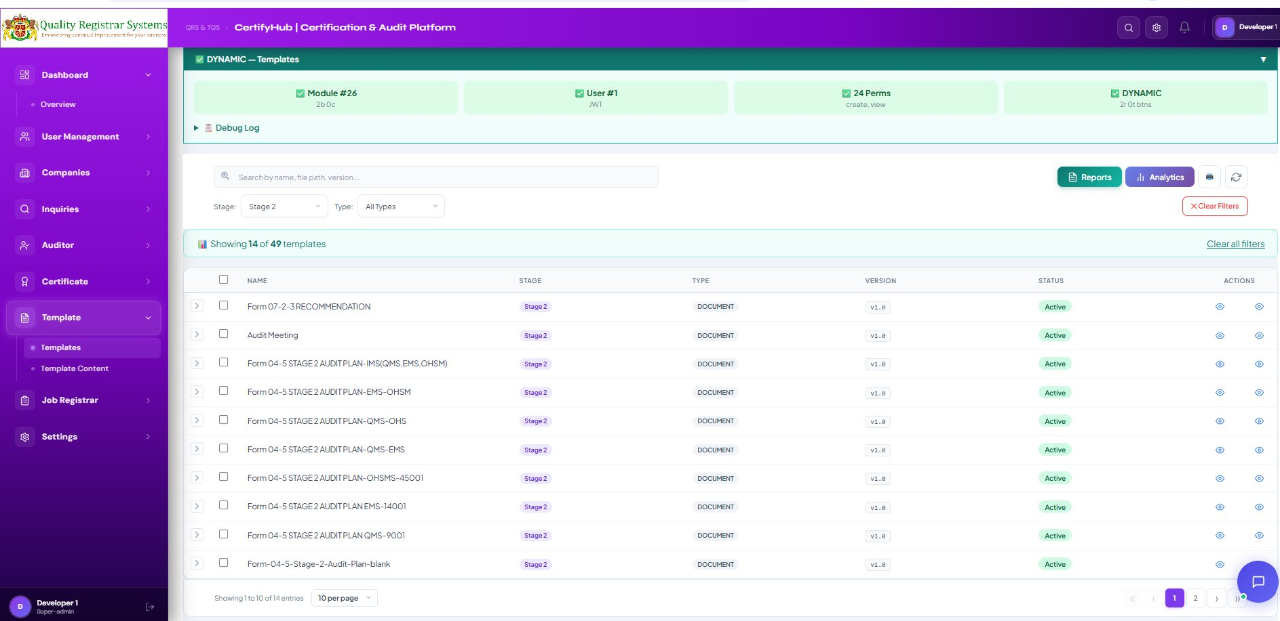
Figure 12.2 — Templates list filtered by Stage 2, showing 14 of 49 templates.

Stage 2 Templates You'll See
- Form 07-2-3 RECOMMENDATION — certification recommendation written after Stage 2.
- Audit Meeting — agenda and minutes for opening / closing meetings.
- Form 04-5 STAGE 2 AUDIT PLAN-IMS(QMS,EMS,OHSM) — integrated Stage 2 plan.
- Form 04-5 STAGE 2 AUDIT PLAN-EMS-OHSM, -QMS-OHS, -QMS-EMS, -OHSMS-45001, EMS-14001, QMS-9001 — one plan per standard / combination.
- Form-04-5-Stage-2-Audit-Plan-blank — generic Stage 2 audit plan.

List Columns (both Stage 1 and Stage 2)
Column | Description
Name | Internal template name (e.g. Form 04-5 STAGE 1 AUDIT PLAN-QMS-OHS).
Stage | Stage 1 or Stage 2 (colour tag).
Type | DOCUMENT or CERTIFICATE.
Version | Semantic version (v1.0, v1.1, v2.0 …).
Status | Active (green) — usable for generation; Inactive (grey) — hidden.
Actions | 👁 Open PDF • 👁 View metadata.

Search & Filters
- Search by name, file path, version — live search.
- Stage — Stage 1 / Stage 2.
- Type — All Types / DOCUMENT / CERTIFICATE.
- Reports / Analytics — top-right buttons.
- Clear Filters — red button.

12.3 Adding a New Template — Step by Step
Click the + Add Template button (or the equivalent action in the template module's top-bar). A green-themed modal titled New Template — Register a new PDF document or certificate template opens.
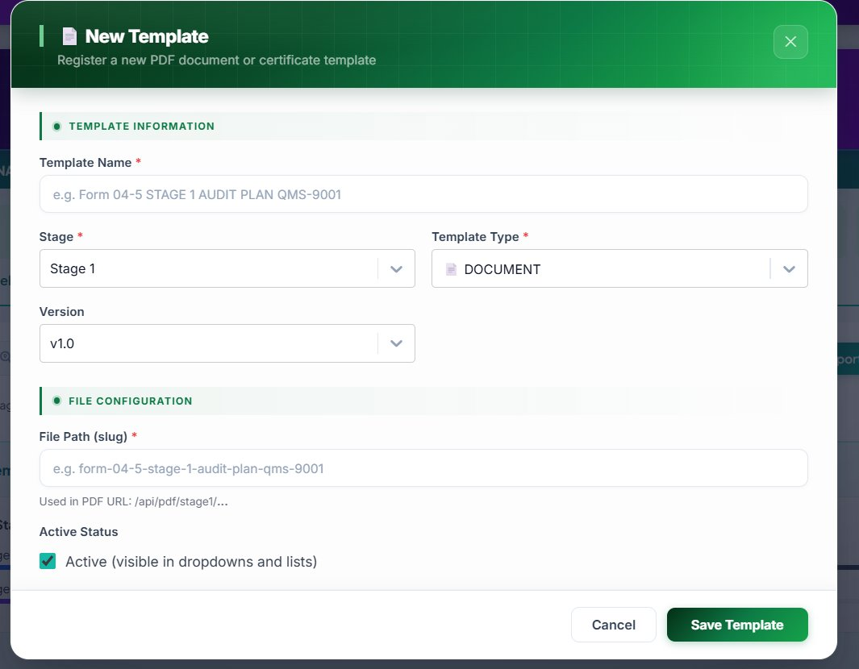
Figure 12.3 — New Template form.
Section A • Template Information
Step 1 ▸ Enter the Template Name
Type the internal name following the existing convention, e.g. Form 04-5 STAGE 1 AUDIT PLAN QMS-9001. Mandatory.
Step 2 ▸ Select the Stage
Open Stage dropdown and choose Stage 1 or Stage 2. Mandatory.
Step 3 ▸ Select the Template Type
Open Template Type dropdown — pick DOCUMENT for forms/reports/checklists, or CERTIFICATE for certificate templates. Mandatory.
Step 4 ▸ Set the Version
Open Version dropdown — start at v1.0 for a new template, or pick the next semantic version when uploading a revision (v1.1 for a minor change, v2.0 for a major rewrite).
Section B • File Configuration
Step 5 ▸ Enter the File Path (slug)
Type the slug used in the file URL, lowercase with hyphens, e.g. form-04-5-stage-1-audit-plan-qms-9001. The helper text shows the resulting PDF URL: /api/pdf/stage1/…. Mandatory.
Step 6 ▸ Tick Active Status
Check Active (visible in dropdowns and lists) to make the template immediately usable. Untick to keep it hidden while you upload supporting files or refine the content.
Step 7 ▸ Save
Click the green Save Template button at the bottom-right. The template appears in the list and is available everywhere it can be applied — audit scheduling, document generation, certificate issuance.
✓ Template names are used in file names of the generated documents. Follow the existing prefix convention (Form NN-N STAGE X …) — it makes the audit folder for each company self-sorting.

12.4 Template Content (sub-page)
Templates → Template Content is where you define the actual items inside each template — checklist questions, scoring rules, time slots, section headers. This is the difference between an empty form and a fully usable audit checklist.
- Open a template → Manage Items → add / edit / reorder checklist items.
- Set the Time Slot for each section so the auditor can plan the day.
- Mark items as Mandatory or Optional.
- Save — the new items show up in every future audit using this template.

13. Module — Job Registrar

Every audit becomes a Job. The Job Registrar is the operational logbook that links the Company, the Auditor, the Standards, the Templates and the generated documents into one record per audit cycle.

Relationship with Audit Management
Audit Management (Module 9) is the source of every Job Registrar entry. The flow is:
- Audit is scheduled in Audit Management → a Job is auto-created here.
- Auditor completes Stage 1 → marks the stage Completed in Audit Management.
- Scheme Department clicks Generate Document in Audit Management — the platform produces the full Stage 1 document pack from the selected template within ~2 minutes (see Module 9.3).
- All generated files are attached automatically to this Job's record, visible under the Job's documents tab.
- The same flow runs for Stage 2 → on closure, the Generate Certificate action becomes available in Module 14.

Job Record Fields
Field | Example
Company Name | MGL Geotechnical Laboratory
Doc Review Date | 06 Dec 2025
On-Site Audit Date | 08 Dec 2025
No. of Employees | 50
Stage | Stage 1 / Stage 2
Auditor | Mr Muhammad Hanzala
Template | Form 04-5 STAGE 1 AUDIT PLAN QMS
Standards | ISO 27001:2013, ISO 45001:2018
NACE / EAC Codes | 34.5
Risk Level | Low / Medium / High
Job Codes | ISMS:5381, OHASMS:1479
Documents | All Stage 1 / 2 files generated by Audit Management.
Status | Open / Closed (auto-closes when certificate is issued).

List View Workflow
- Open Job Registrar → Job List from the sidebar.
- Filter by Stage, Standard, Auditor, Risk or Date Range.
- Click View on any row to see the company, audit, all generated documents and timeline events.
- Closed jobs remain searchable forever — they are the operational audit trail.
📊 Reports Button — Every Job Registrar module list view has a green Reports button on the top-right. Apply any filters first (date range, month, status, group, standard, etc.) and then click Reports — the platform generates a styled PDF / Excel of exactly the rows currently visible. The same applies on every list view in the platform — Companies, Inquiries, Certificates, Job Registrar, Standards, Countries — so you always get a report that matches what you see on screen.

✓ You don't create Job entries by hand. They appear automatically the moment an audit is scheduled in Audit Management. The Job is the place where Scheme & Audit teams collaborate on the actual paperwork.

13.1 Reports — Filtered Report Generation
The Job Registrar Reports button produces a definitive view of how much certification work the platform has executed — every Job is one audit cycle, so this is the report the Scheme Department lives by. Filter by Stage, Standard, Auditor, Risk level or date range, then export to PDF (sharable summary) or Excel (operational sheet).

Step-by-Step — Generating a Job Registrar Report
Step 1 ▸ Apply filters
Stage (1 / 2 / Surveillance / Recertification), Standard (ISO 9001 / 14001 / 45001 / …), Auditor (specific lead auditor), Risk (High / Medium / Low), Date Range.
Step 2 ▸ Pick the slice you need
By auditor — "all of Mr Hanzala's audits this quarter"; by standard — "every ISO 27001 cycle this year"; by status — "open jobs only".
Step 3 ▸ Click Reports → PDF / Excel
PDF is preferred for executive summaries (workload by auditor, completion rates). Excel when you need to pivot or chart.
Step 4 ▸ Save / Distribute
File pattern: JobRegistrarReport_<YYYY-MM-DD>_<filters>.pdf — e.g. JobRegistrarReport_2026-05-14_Stage2_OHSMS.pdf.

What's Inside the Job Registrar Report
Section | Contents
Cover | Title · Date · Filter summary · Generator (user).
Workload block | Total jobs · Open / Closed split · By Stage · By Standard.
By auditor | Count of jobs per lead auditor with average completion time. Highlights workload imbalance — useful at quarter-end.
Risk block | Count by Risk level (High / Medium / Low) — drives where Scheme Dept. focuses surveillance attention.
Detail table | Job code · Company · Stage · Standards · Lead Auditor · Doc Review Date · On-Site Date · No. of Employees · NACE/EAC · Status · Generated docs count.
Documents column | Mini summary of how many files the Scheme generated for each Job (8 docs · 12 docs · …). Quick visual of which jobs are document-complete.
Footer | Page X of Y · QRS contact · Confidentiality.

Use Cases by Role
Role | Typical Filter Combination | What They Use the Report For
Scheme Dept. Head | All Open · This month. | "How much has my team produced?" — number of jobs closed, average doc generation time, jobs per auditor.
Coordinator | Date Range = This week. | Operational worklist — audits coming up, NCRs to chase, jobs ready to close.
Auditor | Auditor = me · This year. | Personal audit log — every cycle I led, in one PDF, useful for renewing IRCA / ISO accreditation.
Super-admin | Whole year. | Annual operations KPI — total audits delivered, average lead time, workload balance.
Risk / QA Officer | Risk Level = High. | Surveillance plan — which clients require closer follow-up.

✓ This is the Scheme Department's productivity dashboard — it shows exactly how much audit pack work the team has produced. Run it monthly and the management deck writes itself.

14. Module — Certificate (Draft + Digital)

Once Stage 2 is completed and all NCRs are closed, the platform issues the certificate. Every certificate is fully digital: the system assigns a unique certificate number based on the standard, attaches a QR code, a verification URL, a token and a digital fingerprint that together make the certificate impossible to forge. Clients can verify in seconds by scanning the QR code or entering the certificate number on the public verification page.

14.1 Certificates Module — List View
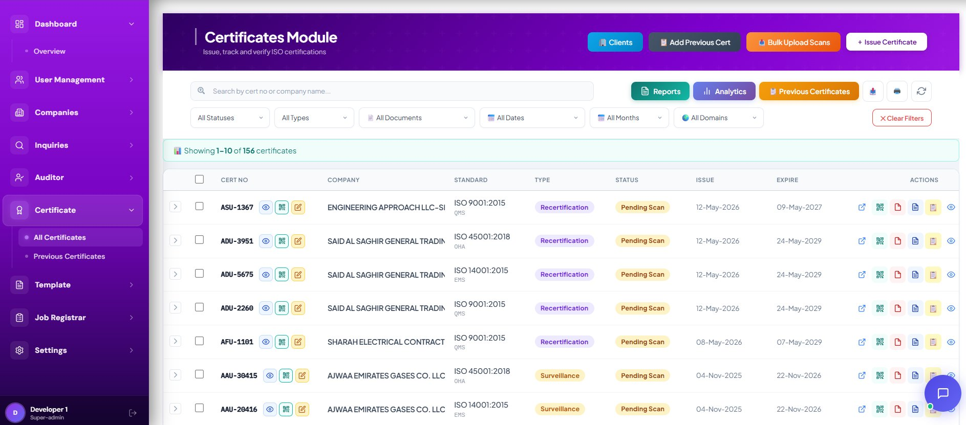
Figure 14.1 — Certificates Module list view, showing 156 certificates with status, type and validity dates.

Top-Bar Actions
Button | Purpose
Clients (blue) | Opens the client picker — choose a company before issuing a certificate.
Add Previous Cert (dark) | Adds a legacy certificate record (links to Module 15).
Bulk Upload Scans (orange) | Drag-and-drop multiple signed PDF scans; the platform auto-matches each file to its certificate number.
+ Issue Certificate (white) | Opens the Issue Certificate form — the main daily action.
Reports (green) | Export the filtered list to PDF / Excel.
Analytics (purple) | Dashboards: certs issued per month, by standard, by domain, expiring soon.
Previous Certificates (orange) | Jump to Module 15 (the historical archive).
Clear Filters (red) | Reset every filter at once.

List Columns
Column | Description | Example
Cert No | Unique certificate number generated based on the standard. | UAE-DU-OHA-8K57Q
Company | Certified organisation. | ENGINEERING APPROACH LLC
Standard | ISO standard + short code. | ISO 9001:2015 • QMS
Type | Initial / Surveillance / Recertification (colour-tagged). | Recertification
Status | Pending Scan / Active / Suspended / Withdrawn / Expired. | Pending Scan
Issue | Issue date. | 12-May-2026
Expire | Expiry date (typically 3 years after issue). | 09-May-2027
Actions | Open external page • QR code • Edit • PDF • View • Verify. | (icons)

Filters
- All Statuses — Pending Scan / Active / Expired / Withdrawn
- All Types — Initial / Surveillance / Recertification / Transfer
- All Documents — Has scan / Missing scan
- All Dates and All Months — Issue date range filters
- All Domains — Local (qrsyst.com) / International

14.2 Issuing a Certificate — Step by Step
Click + Issue Certificate. The platform pre-fills almost everything from the audit data — the user only confirms dates and click Save. The result is a draft certificate; promoting it to Digital locks the certificate number, generates the QR code and exposes the public verification URL.
Step 1 ▸ Open the Issue Certificate form
Click the white + Issue Certificate button in the top-right of the Certificates Module.
Step 2 ▸ Pick the Company
Search and select the certified company. The form auto-fills Company name, Standards, City, Country, EA Codes and Scope of Work from the company record.
Step 3 ▸ Confirm the Standard & Standard Short Code
Standard short codes determine the certificate-number prefix: QMS (ISO 9001), EMS (ISO 14001), OHA (ISO 45001), ISMS (ISO 27001), FSMS (ISO 22000), and so on.
Step 4 ▸ Set Validity Dates
Enter the Issue Date (today by default) and Expire Date (3 years after issue is standard). If this is a renewal, the Originally Registered Date is carried from the previous certificate.
Step 5 ▸ Set Verification Domain
Choose Local (qrsyst.com) for UAE / GCC clients, or International for clients verifying from outside the local accreditation scope.
Step 6 ▸ Save the Draft
Click Save. The certificate appears with status Pending Scan. Use the draft PDF for internal review.
Step 7 ▸ Promote to Digital
Once approved, click Generate Digital Certificate. The platform:
- Assigns the certificate number (e.g. UAE-DU-OHA-8K57Q).
- Generates the QR code image.
- Creates the public Verification URL with token & fingerprint.
- Locks the record — no further edits without admin override.

14.3 Certificate Details Modal
Clicking the eye icon on any certificate row opens the Certificate Details modal. It is split into four logical sections that you can scroll through: Certificate Information, Company & Standard, Validity Dates, and QR Code & Public Verification.
Top — Certificate Information & Company
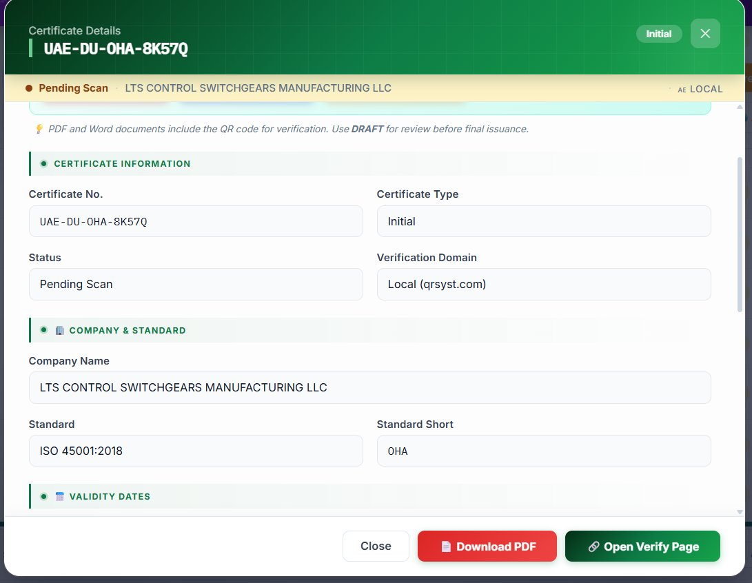
Figure 14.2 — Certificate Details modal, top: Certificate Information, Company & Standard.

Fields
Field | Description
Certificate No. | The unique number (also the modal title). Auto-generated, read-only.
Certificate Type | Initial / Surveillance / Recertification.
Status | Pending Scan / Active / Expired / Withdrawn.
Verification Domain | Local (qrsyst.com) — for local accreditation; International — for cross-border.
Company Name | Read-only from the company record.
Standard / Short | Full ISO code + short code (used in the cert number prefix).
▸ “PDF and Word documents include the QR code for verification. Use DRAFT for review before final issuance.” This message appears at the top of the modal — read it carefully before clicking Download.

Bottom — Validity & Verification
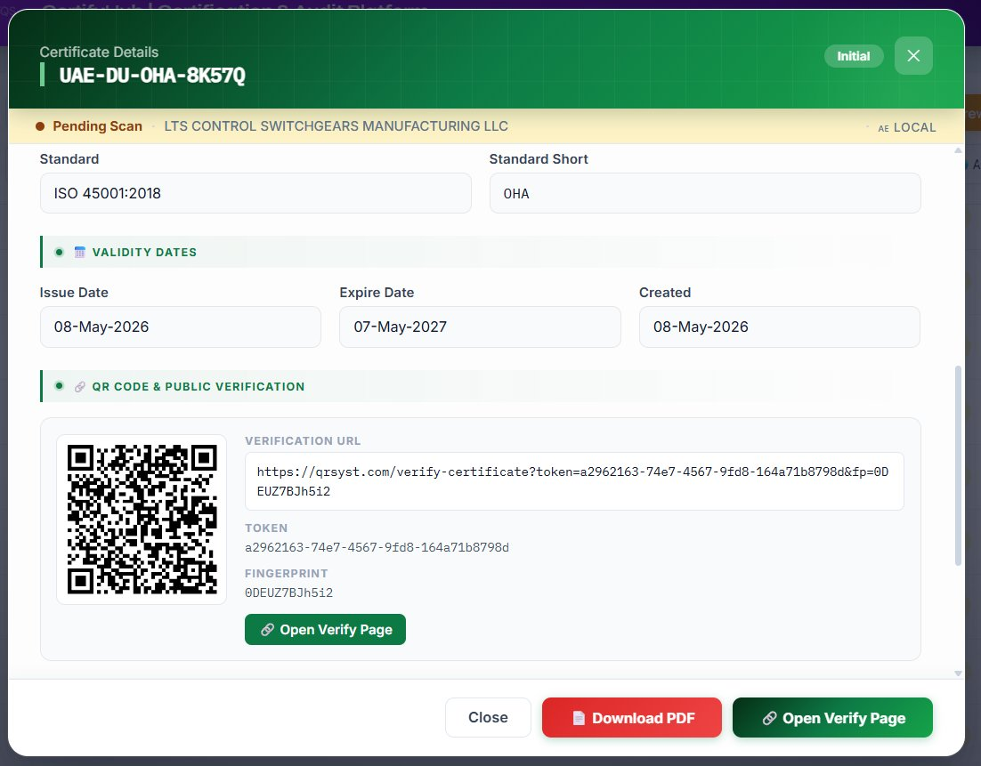
Figure 14.3 — Certificate Details modal, bottom: Validity Dates, QR code, Verification URL, token and fingerprint.

Validity Dates
- Issue Date — when the certificate was issued (e.g. 08-May-2026).
- Expire Date — when it expires (e.g. 07-May-2027).
- Created — when the record was created in the platform.

QR Code & Public Verification
Every digital certificate carries three linked artefacts that make forgery effectively impossible:
Artefact | Example | Purpose
QR Code | (image) | Scan with any phone — opens the verification page directly.
Verification URL | https://qrsyst.com/verify-certificate?token=…&fp=… | Opens the public page that proves the certificate is valid.
Token | a2962163-74e7-4567-9fd8-164a71b8798d | Server-side identifier that ties the URL to the certificate.
Fingerprint | 0DEUZ7BJh5i2 | Cryptographic digest of the certificate contents — changing any field invalidates it.

Modal Footer Buttons
- Open Verify Page (green) — opens the public verification URL in a new tab.
- Download PDF (red) — downloads the certificate PDF with the QR code embedded.
- Close — closes the modal.

14.4 Certificate QR Code Modal
Clicking the QR icon on a certificate row opens a focused Certificate QR Code modal — used to print the QR code on physical certificates, share with clients, or embed in customer-facing documents.
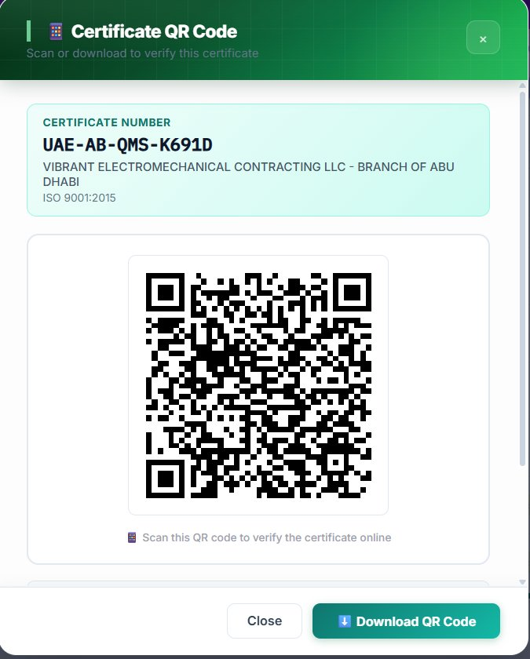
Figure 14.4 — Certificate QR Code modal.

What the Modal Shows
- Certificate Number — e.g. UAE-AB-QMS-K691D.
- Company name — e.g. VIBRANT ELECTROMECHANICAL CONTRACTING LLC - BRANCH OF ABU DHABI.
- Standard — e.g. ISO 9001:2015.
- QR code image — large and scannable, with the instruction *Scan this QR code to verify the certificate online*.
- Download QR Code button — downloads the PNG for use in print or other documents.

Public Verification — How Clients Verify
- Scan the QR code with any smartphone camera — the verification page opens automatically.
- Or visit the verification URL manually and enter the Certificate Number or Fingerprint.
- The page shows: company name, standard, issue date, valid / expired status.
- If the certificate is suspended or withdrawn, the page shows a clear warning — clients cannot be fooled.
✓ No one can produce a fake certificate. The combination of unique certificate number + token + fingerprint + QR code means any tampering immediately fails the verification. The platform is the single source of truth.

14.5 Bulk Upload Scans
After signing physical certificates, you usually have a folder of scanned PDFs. Instead of attaching each one by hand, use Bulk Upload Scans to upload up to 200 files at once — the platform reads the filename, finds the matching certificate, attaches the scan, and flips the status to Active.
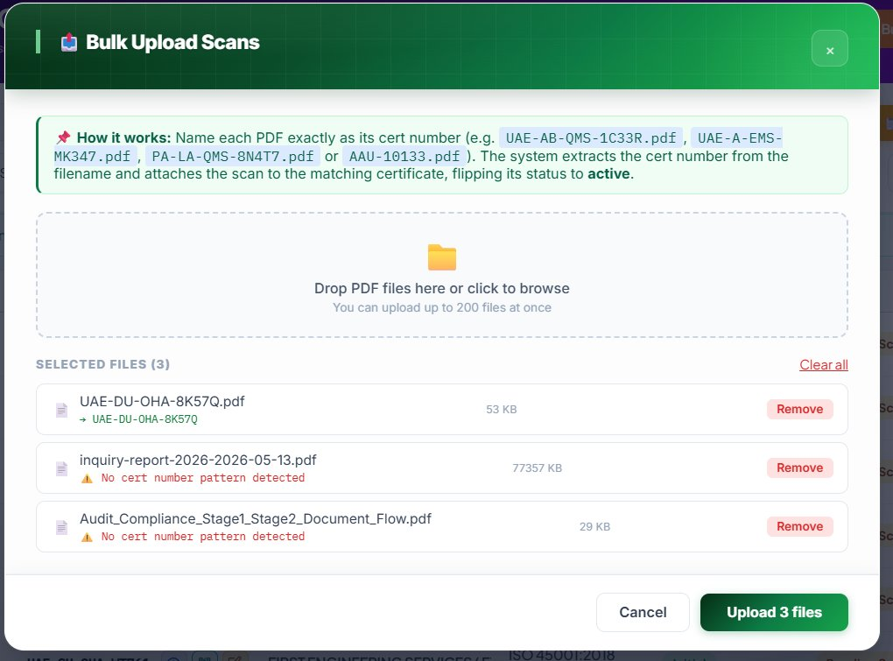
Figure 14.5 — Bulk Upload Scans modal.

How it Works
ℹ Name each PDF exactly as its certificate number, e.g. UAE-AB-QMS-1C33R.pdf, UAE-A-EMS-MK347.pdf, PA-LA-QMS-8N4T7.pdf or AAU-10133.pdf. The system extracts the certificate number from the filename and attaches the scan to the matching certificate, flipping its status to Active.

Step-by-Step
- Click the orange Bulk Upload Scans button on the Certificates Module top-bar.
- Drag and drop your PDF files into the drop zone — or click to browse.
- The platform validates each filename:
  - Green ✓ — cert number pattern matched (e.g. UAE-DU-OHA-8K57Q.pdf → UAE-DU-OHA-8K57Q).
  - Yellow ⚠ — no cert number pattern detected (file will be skipped).
- Review the file list, click Remove on any file you don't want.
- Click Upload N files — the platform attaches every matched scan in one batch.
- Each successfully matched certificate moves from Pending Scan to Active automatically.

14.6 Why Going Digital Matters
Aspect | Digital Certificate
Number generation | Automatic, based on standard short-code + region + sequence. No duplicates possible.
Forgery resistance | Token + fingerprint + QR code cross-check. Any tampering breaks the verification.
Verification time | Seconds — scan QR or enter cert number.
Distribution | Email link, embed QR on letterheads, print on signed PDFs.
Suspension / withdrawal | Update status in the platform — public page instantly shows the new state.
Audit trail | Every issue, edit, suspension, renewal logged with user and timestamp.
Renewal | Originally Registered date is carried forward — continuity preserved.

14.7 Public Verification Pages — What Clients See
Section 14.4 showed the in-platform QR code modal. This section shows what the end-user — a client, a procurement officer, a regulator — sees when they verify the certificate from outside the platform. Two entry paths lead to the same place: scanning the QR code on the certificate, or typing the certificate number into the public verification page on the corporate website.
ℹ Two entry paths → one verification result. (1) Scan the QR code printed on the PDF certificate with any phone camera → the verification result page opens directly. (2) Visit https://qrs.ae/verify-certificate (or whichever public domain is configured under Settings → Verification Domain) → type the certificate number → the same verification result page opens. Both paths land on the same page; only the entry differs.

Path 1 — Verify by Certificate Number
From the corporate website, the user clicks Verify Certificate in the top navigation. A blue-themed page titled Certificate Verification appears with a single search box and an instruction line: "Search by certificate number to verify certifications."
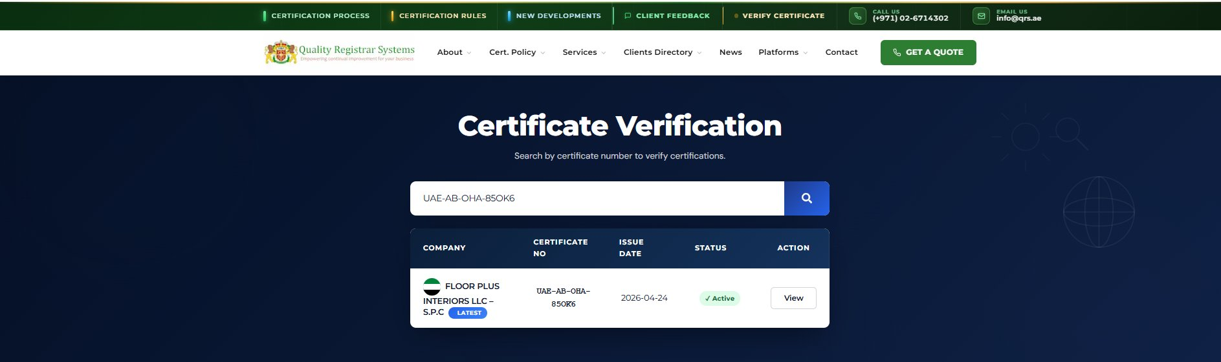
Figure 14.6 — Certificate Verification page on the QRS public website. The user types the certificate number (e.g. UAE-AB-OHA-850K6) and clicks the search icon. Matching results appear below with the company name, certificate number, issue date, status badge (✓ Active / Expired / Withdrawn) and a View button.

Result Row Fields
Field | Description | Example
Company | Flag icon + legal name of the certified company. | 🇦🇪 FLOOR PLUS INTERIORS LLC – S.P.C
Certificate No | Exact certificate number entered for the search. | UAE-AB-OHA-850K6
Issue Date | When the certificate was issued. | 2026-04-24
Status | Live status badge — Active / Expired / Withdrawn / Suspended. | ✓ Active (green)
LATEST tag | Blue badge on the most recent renewal — useful when a client has historic certificates. | LATEST
Action | View button — opens the Confirmation of Certificate page (Path 2 below). | (button)

Path 2 — Verification Result (Confirmation of Certificate)
Whether the user came from the QR scan or clicked View from the search result, they land on the same Confirmation of Certificate page. The page is split into four blocks: a coloured status banner, the certificate body, the gold-seal authorised signatory block, and a dark footer carrying the verification reference.
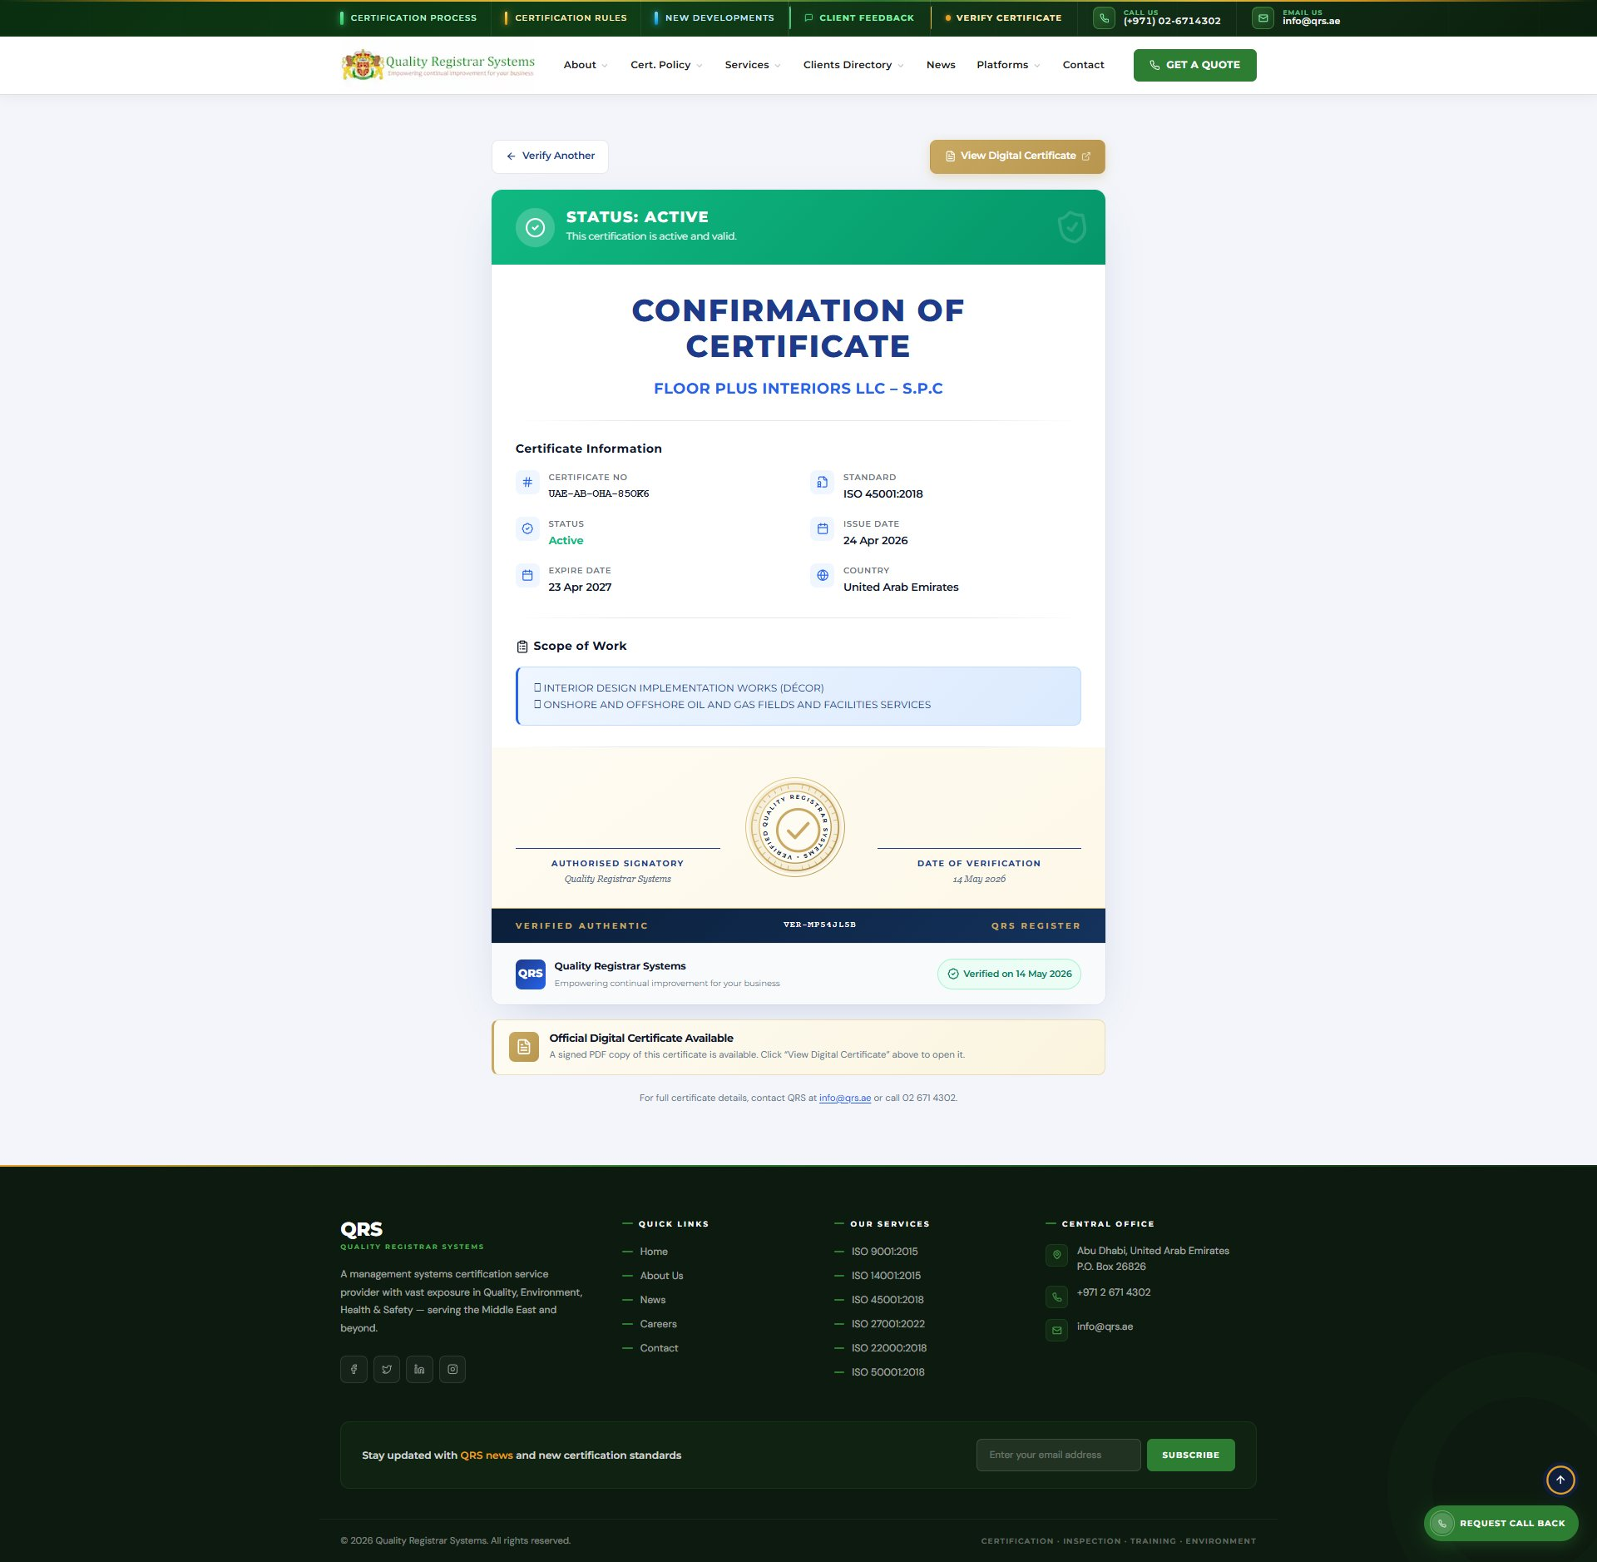
Figure 14.7 — Confirmation of Certificate result page on qrs.ae. The page shows a green STATUS: ACTIVE banner, the full certificate body (number, standard, status, issue & expire dates, country, scope of work), the gold authorised-signatory seal, and the dark verification footer with the unique verification reference (e.g. VER-MP54JLSB).

Status Banner Colours
Banner | Meaning
STATUS: ACTIVE (green) | Certificate is live and valid. The block reads "This certification is active and valid."
STATUS: EXPIRED (orange) | Certificate has passed its expire date. The block recommends contacting the company for a renewal.
STATUS: WITHDRAWN (red) | Certificate has been withdrawn / cancelled by QRS. The block warns it must not be relied upon.
STATUS: SUSPENDED (amber) | Temporarily suspended pending corrective action. The block notes the certificate is not in effect during the suspension.

Certificate Information Block
The Certificate Information block on the result page shows exactly what a verifier needs in the order they expect it: Certificate No, Standard, Status, Issue Date, Expire Date, Country, and Scope of Work. The Scope of Work is shown in a light-blue bordered card to mirror the printed certificate.

"View Digital Certificate" Button
Two buttons sit above the verification page: ← Verify Another (returns to the search page) and the gold View Digital Certificate ↗ button. Clicking View Digital Certificate opens the full digital PDF copy of the certificate in a new tab — the same PDF that was generated when the certificate was issued, complete with the QR code, fingerprint, and all formatting. This is the document the client typically downloads and attaches to tender submissions or supplier portals.
ℹ Official Digital Certificate Available — A pale-gold info card sits below the certificate body on the result page with the message: "A signed PDF copy of this certificate is available. Click 'View Digital Certificate' above to open it." This is to remind verifiers that the PDF — not the web page — is the artefact they should download and store.

Verification Reference (VER-XXXXXXX)
The dark navy footer on the result page shows three pieces of information from left to right: VERIFIED AUTHENTIC (label), the unique verification reference number (e.g. VER-MP54JLSB), and QRS REGISTER (the source authority). This reference is regenerated on every page load and is the audit trail showing that the verification did happen — useful when a regulator later asks "how do I know you verified it?"
A small chip below the QRS branding row reads "✓ Verified on 14 May 2026" with the date being the date the verification was performed (the today date when the page is opened). This is a timestamp for the verifier's own records — they can screenshot the page to keep evidence that they checked the certificate on that exact date.

End-to-End Verification Journey
Step | What the Verifier Does | What the Platform Shows
1 | Receives the certificate PDF from the supplier. | PDF carries the QR code and the visible certificate number.
2a | OR scans the QR code with a phone camera. | Phone opens https://qrs.ae/verify-certificate?token=…&fp=… directly.
2b | OR visits the QRS public website and clicks Verify Certificate, then types the certificate number. | Search results table shows the matching company with the Active badge and a View button.
3 | Lands on the Confirmation of Certificate page. | Page shows green STATUS: ACTIVE banner + full certificate body + authorised-signatory seal.
4 | Clicks View Digital Certificate (gold button, top-right). | Full digital PDF copy opens in a new tab — same file the company gave them, served from QRS, signed and watermarked.
5 | Optionally screenshots the page and notes the VER-XXXXXXX reference. | VERIFIED AUTHENTIC footer with the unique reference number gives them an audit trail.

✓ Why this matters — A supplier can't fake a QR code on a certificate, because scanning it goes through QRS's servers, not the supplier's. If the cert was withdrawn, the result page shows the withdrawal in real time — even if the supplier is still circulating the original PDF. The certificate number + token + fingerprint + QR code together make forgery effectively impossible: tamper with any field and the verification page rejects it.

What if the Certificate Number is Not Found?
If the typed certificate number does not match any record, the page shows a red Not Found result with the message "No certificate found with this number. Please check the number and try again, or contact QRS at info@qrs.ae." This is also what happens if someone tries to forge a certificate number that has never been issued.
⚠ If the certificate is found but the status is anything other than Active (Expired, Withdrawn, Suspended) — the supplier is no longer certified for that scope. The verifier should treat the supplier accordingly: ask for a current certificate, escalate to procurement, or remove them from approved-supplier lists.

14.8 Reports — Filtered Report Generation
The Certificate module's Reports button delivers the artefact at the end of the workflow — what's been issued, what's draft, what's active, what's expiring, what's been withdrawn. This is the report that procurement officers, accreditation bodies and the management board all want to see. The Scheme Department runs it after every certificate batch; the Coordinator runs it monthly to plan the renewal campaign.

Step-by-Step — Generating a Certificates Report
Step 1 ▸ Apply filters
Status (Pending Scan / Active / Expired / Withdrawn / Suspended), Certificate Type (Initial / Surveillance / Recertification), Verification Domain (Local / International), Date Range (issue date or expiry date).
Step 2 ▸ Pick the report angle
Issued this month — Status = Active · Issue Date this month. Expiring soon — Expire Date in the next 30 / 60 / 90 days. Draft pending scan — Status = Pending Scan.
Step 3 ▸ Click Reports → PDF / Excel
PDF for management and clients; Excel for the bulk-renewal mail-merge.
Step 4 ▸ Save / Distribute
File pattern: CertificatesReport_<YYYY-MM-DD>_<filters>.pdf — e.g. CertificatesReport_2026-05-14_Active_Expiring60days.pdf.

What's Inside the Certificates Report
Section | Contents
Cover | Title · Date · Filter summary · Generator (user).
Status block | Count by Status — Active / Pending Scan / Expired / Withdrawn / Suspended.
Issuance block | By Certificate Type — Initial / Surveillance / Recertification. Useful to see the renewal share vs new-client share.
By Standard | Count of certificates per ISO standard — QMS / EMS / OHSMS / ISMS / FSMS / FMS / EnMS.
Expiring block | Certificates expiring in the next 30 / 60 / 90 days, with the client contact email pre-listed — the input to the renewal campaign.
Detail table | Cert No · Company · Standard · Type · Issue Date · Expire Date · Status · Verification Domain · Originally Registered · Days to Expiry.
Draft pipeline | Certificates with Status = Pending Scan — what's waiting for signed scans to be uploaded via Bulk Upload Scans.
Footer | Page X of Y · QRS contact · Confidentiality.

Use Cases by Role
Role | Typical Filter Combination | What They Use the Report For
Scheme Dept. | Status = Pending Scan. | Worklist — which signed scans are still needed. Drives the bulk-upload session.
Coordinator | Expire Date next 60 days. | Renewal pipeline — companies to contact this month. Output is the renewal mail-merge list.
Marketing | Status = Active · Issue Date last 12 months. | Customer-success report — count of active certifications, broken down by standard for the website's "Trusted by …" page.
Super-admin | Whole year · Status = Withdrawn. | Compliance audit — withdrawals and why, for accreditation review.
Management | Certificate Type = Initial · This quarter. | Sales pipeline output — new-client certifications closed this quarter.

ℹ Expiry early-warning — Run the Expire Date next 60 days filter on the first working day of every month. The output is your monthly renewal-call list. A renewal opened 60 days before expiry has a 90%+ retention rate; opened 7 days before, retention drops to ~60%. The report is the early warning.

✓ Draft / Digital split — Run the Status = Pending Scan filter to see the draft pipeline; run Status = Active to see what's live; run Status = Expired to see what's gone. The Certificate Reports show the full lifecycle in one place.

14A. Module — Chat (Internal Messaging)

The Chat module is the platform's built-in internal messaging tool — a WhatsApp-style space where Marketing, the Coordinator and the Scheme Department can communicate without leaving the platform. Whether it's an urgent question about a client's scope, a quick handover between Stage 1 and Stage 2 audits, or a file that needs reviewing right now, Chat is faster than email and keeps the conversation linked to the people who actually work on the certification.

Who Uses Chat
Role | Typical Use of Chat
Marketing | Ask the Scheme Dept. to clarify scope before submitting an inquiry; chase up missing inputs.
Coordinator | Confirm audit dates with the auditor; share schedule files with Marketing; relay client requests.
Scheme Department | Send draft audit packs for review; flag NCRs to the Coordinator; co-ordinate certificate issuance.
Auditor | Confirm arrival logistics, share photos / scans from site, escalate findings in real time.
Super-admin | Broadcast platform-wide notices, support users, audit chat history for compliance.

ℹ Why an in-platform chat and not WhatsApp? — Two reasons. (1) Compliance: every message is logged inside the platform and tied to the same user IDs that own the audits and certificates, so the audit trail is complete. (2) Context: when you chat about "that audit for Bin Harmal", a future auditor can find the conversation against the company record, not buried in a personal phone.

14A.1 Opening Chat
Chat is always one tap away. The floating purple chat button is pinned to the bottom-right corner of every page in the platform (Dashboard, Companies, Inquiries, Audit Compliance, Job Registrar, Certificates — every screen). Click it to open the chat panel; click the X on the same button to close it.
Unread messages show a red badge with the unread count on the floating button. When you open the panel the badge clears for the conversations you've read.

14A.2 Starting a New Message
Click + New Message (or the pencil-on-paper icon inside the chat panel) to open the Team Members directory. The header shows the total number of teammates currently in the platform — e.g. 22 team members.
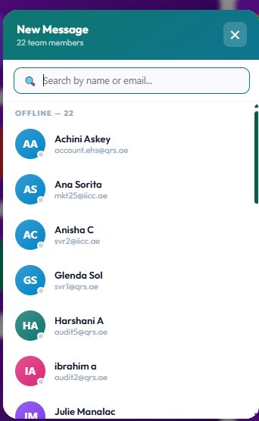
Figure 14A.1 — New Message dialog. Search by name or email at the top; the list below shows every teammate with their avatar (colour-coded initials), full name, and work email. A green dot on the avatar means Online; greyed-out OFFLINE entries are grouped under the OFFLINE — N header.

Anatomy of the New Message Dialog
Element | What It Shows / Does
Header strip (teal) | Title "New Message" and the live count of teammates (e.g. "22 team members").
Search bar | Type any part of a name or email — list filters live as you type. Useful when the directory is large.
Status group header | ONLINE — N at the top (if any), then OFFLINE — N. The split makes it obvious who you can chat with right now.
User row | Coloured circular avatar (initials), full name, work email — click the row to open a one-to-one chat.
Status dot on avatar | Green = Online · Grey / no dot = Offline · Yellow = Away · Red = Do Not Disturb.
Close (X, top-right) | Closes the New Message dialog without starting a chat.

ℹ Tip — Avatars use the first letter of the first name + first letter of the last name (e.g. "Harshani A" → HA). Each user is given a stable background colour so you can recognise teammates at a glance, even without reading the name.

14A.3 The Chat Window
Selecting a teammate (or opening an existing conversation) opens the chat window. The header shows the other person's avatar, full name (e.g. KHOLA SAJID) and live status (Online / Offline / typing…). On the right of the header sit two icons — a magnifying-glass (search inside this conversation) and a diagonal arrows icon (expand the chat to full-screen mode for long handovers).
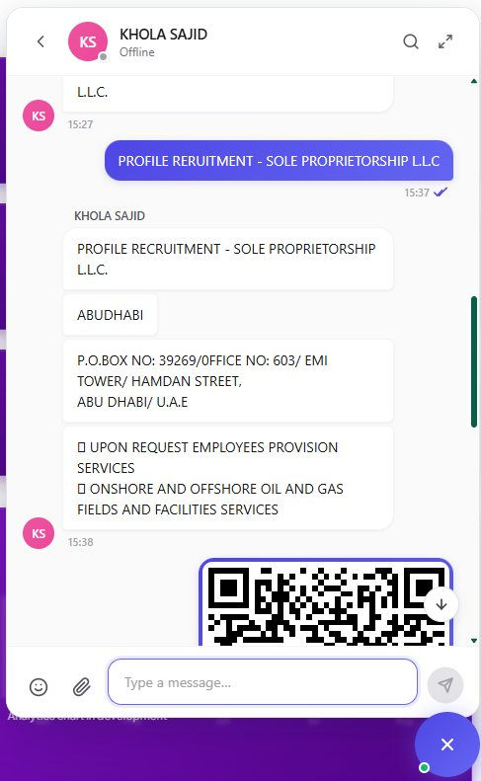
Figure 14A.2 — Chat conversation view. Incoming messages appear on the left with the sender's avatar and timestamp; messages you sent appear on the right in blue with white text. Files, images, QR codes and forwarded company profiles render inline. The composer at the bottom carries emoji, attachment and send actions. The floating purple X (bottom-right) closes the chat panel.

Reading the Conversation
Direction | Appearance
Incoming (from the other person) | Left-aligned message bubble in white with grey border, sender's avatar to the left, sender name above on the first message of a burst, timestamp below.
Outgoing (from you) | Right-aligned bubble in blue (purple gradient on hover) with white text, no avatar, single ✓ when delivered, double ✓ when read.
System notice | Centred grey pill — "Achini joined the group", "Khola pinned this message", "3 new messages" etc.
Date divider | Centred faint line with the date label — "Today", "Yesterday", "14 May 2026".

14A.4 Sending Messages, Files & Forwarded Records
The composer at the bottom of the chat window has four controls — emoji, attachment, the text input, and Send. The text input grows as you type; press Enter to send, Shift+Enter for a new line.

Composer Controls
Control | What It Does
Emoji 😊 | Opens the emoji picker — categorised, with a search box. Pick to insert at the cursor.
Attachment 📎 | Opens the file picker. Supports PDF, DOCX, XLSX, PNG, JPG up to 25 MB per file. Multiple files can be sent in one message.
Text input | Type your message. Live spell-check is on by default; @ to mention a teammate (turns into a clickable chip).
Send ✈ | Sends the message. Greyed out when the input is empty. Keyboard: Enter to send.

Three Things You Can Send
Step A ▸ Plain text
Just type and press Enter. Supports basic formatting — **bold**, *italic*, `code`, and clickable URLs.
Step B ▸ Attachments
Click the paperclip, pick one or more files, optionally add a caption, then Send. PDFs and images render inline; other types show as a file card with name, size and a download button.
Step C ▸ Platform records (company / certificate / audit cards)
Inside a Company, Certificate or Audit record, click the Share to Chat icon (small chat bubble on the top-right of the record) → pick the teammate → the platform sends a rich card containing the legal name, address, scope of work, and a deep link back to the record. This is how the conversation in Figure 14A.2 shows the "PROFILE RECRUITMENT — SOLE PROPRIETORSHIP L.L.C" card. Recipients can tap the card to jump straight to the live record.
ℹ QR codes & verification links — When you share a certificate from the Certificate module, the chat message includes the QR code image and the public verification URL inline. The recipient can tap the QR to verify on the spot, or forward it to a client without leaving Chat.

14A.5 Search, Expand & Conversation Tools

Search Inside the Conversation
Click the magnifying-glass icon in the chat header to open the in-conversation search bar. Type any term — message text, sender name, file name — and the conversation scrolls to each match with the term highlighted. Use the up / down arrows to step between matches.

Expand to Full Screen
The diagonal-arrows icon next to the search expands the chat into a full-screen view — useful when you're sharing your screen on a call, or when you need to review a long handover thread without the rest of the platform crowding the page. Click the same icon to collapse back to the side panel.

Other Per-Message Actions
Action | Where | What It Does
Reply | Hover any message → speech-bubble icon. | Sends a new message that quotes the original above your reply.
Forward | Hover any message → arrow-right icon. | Pick one or more teammates to forward the message (and its attachments) to.
Copy text | Hover any message → copy icon. | Copies the message text to your clipboard.
Delete (for me / for everyone) | Hover your own message → bin icon. | For me removes it from your view; for everyone removes it from all recipients within 1 hour of sending.
Pin | Hover any message → pin icon. | Pins to the conversation's pinned-messages list — useful for important policy or links.

14A.6 Online / Offline / Read Receipts
Indicator | Meaning
Green dot on avatar | User is signed in and active in the last 5 minutes.
Yellow dot on avatar | User is signed in but idle (no input for 15 minutes).
Grey / no dot | User is offline. Messages still deliver and are read when they next sign in.
Single grey tick (✓) on your message | Sent to the server.
Double grey tick (✓✓) on your message | Delivered to the recipient's device.
Double blue tick (✓✓) on your message | Read by the recipient.
typing… | Shown under the recipient's name in the chat header when they're typing a reply.

14A.7 Privacy, Retention & Compliance
Chat conversations are part of the platform's audit trail. Messages are stored encrypted at rest, retained for the configurable retention window (default 3 years), and visible to Super-admins for compliance audits. End-users cannot retrieve messages they have permanently deleted — but Super-admins can, from the platform's compliance console.
⚠ Do not use Chat for confidential client information that should not appear in a regulator audit. Chat is internal-only — never use it to send personal data of clients (passport numbers, financial data) unless the client has consented to be discussed inside the platform. For sensitive matters, use the Documents area on the company record, which carries access-control.

✓ Chat closes the last gap in the certification workflow — between people. Companies, Inquiries, Audits, Schedules, Certificates handle the records; Chat handles the conversations. Together they're a single source of truth for everything that happens around a certification.

15. Module — Previous Certificates

Previous Certificates is the historical archive of certificates issued before the Platform was deployed — typically the last 10 years of legacy records (UAE legacy + overseas + migrations). It stores every old certificate number, the standards it covered, issue and expiry dates, and the original source. The archive is more than just a record: when issuing a new certificate, the platform looks here first to reuse existing certificate numbers for continuity — so clients keep the same number across renewals.

15.1 Previous Certificates — List View
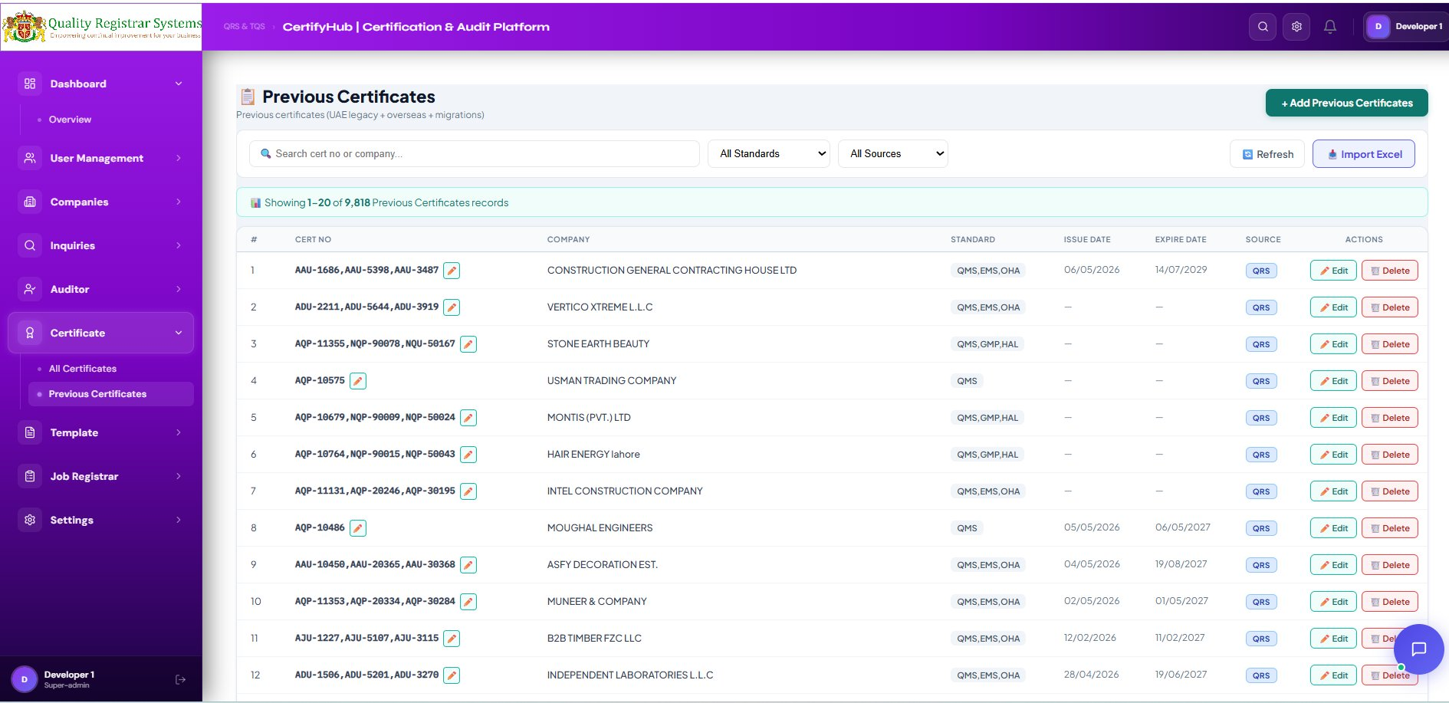
Figure 15.1 — Previous Certificates list view, showing 9,818 records from the historical archive.

Top-Bar
Button / Filter | Purpose
+ Add Previous Certificates (green) | Add a legacy certificate record manually.
Search | Live search by certificate number or company name.
All Standards | Filter to one ISO standard.
All Sources | Filter by source — QRS / TQS / overseas / migration.
Refresh | Reload from server.
Import Excel | Bulk-import a spreadsheet of legacy certificates (Super-admin only).

List Columns
Column | Description | Example
# | Sequence number on the current page. | 1, 2, 3 …
Cert No | Legacy certificate number(s). Multiple when an IMS covers multiple standards. | AAU-1686, AAU-5398, AAU-3487
Company | Client organisation. | CONSTRUCTION GENERAL CONTRACTING HOUSE LTD
Standard | Standards covered, comma-separated short codes. | QMS, EMS, OHA
Issue Date | Original issue date (where known). | 06/05/2026
Expire Date | Original expiry date (where known). | 14/07/2029
Source | Certification body that originally issued it. | QRS
Actions | Edit / Delete. | (buttons)

15.2 Edit Previous Certificate — Form
Clicking the Edit action opens the Edit Previous Certificate modal. The form is structured around the fact that legacy certificates often covered multiple standards under a single Integrated Management System (IMS) — and each standard had its own certificate number.
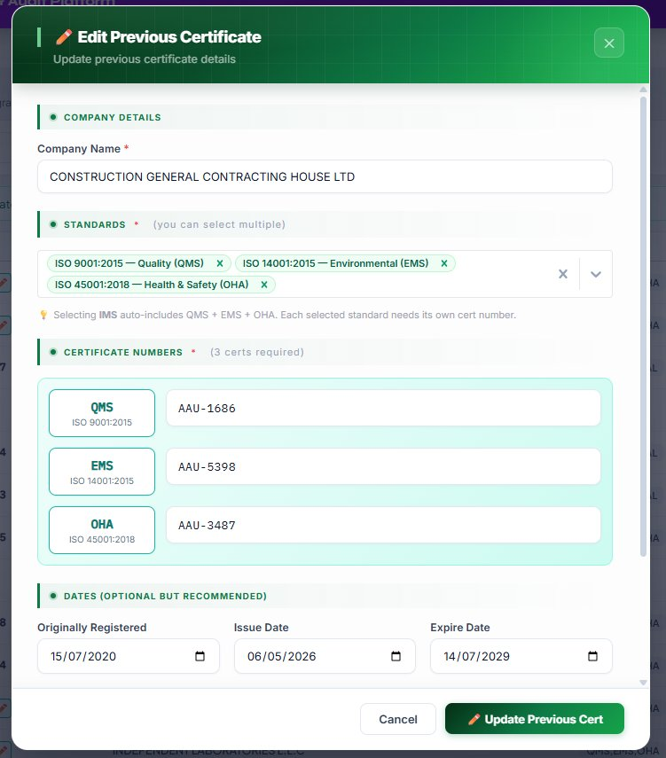
Figure 15.2 — Edit Previous Certificate form: multi-standard with per-standard certificate numbers.
Section A • Company Details
Step 1 ▸ Confirm the Company Name
Pre-filled from the previous record. Edit if a typo needs correction. Mandatory.
Section B • Standards
Step 2 ▸ Select Standards (multiple allowed)
Pick one or more standards. Each tag (e.g. ISO 9001:2015 — Quality (QMS) ✕) is removable. Selecting IMS auto-includes QMS + EMS + OHA. This matches the way legacy certificates were issued.
Section C • Certificate Numbers (one per standard)
Step 3 ▸ Enter a certificate number for each selected standard
If you selected 3 standards (e.g. QMS, EMS, OHA), you must provide 3 certificate numbers, one per row. The form labels each row with the standard short code so there is no confusion: QMS — ISO 9001:2015, EMS — ISO 14001:2015, OHA — ISO 45001:2018. Example values: AAU-1686 (QMS), AAU-5398 (EMS), AAU-3487 (OHA).
Section D • Dates (optional but recommended)
Step 4 ▸ Originally Registered
The very first date the client was certified — used for continuity. Carried forward to all future renewals.
Step 5 ▸ Issue Date and Expire Date
The legacy issue and expiry. If unknown, leave blank — the platform will only use the Originally Registered date.
Step 6 ▸ Save
Click the green Update Previous Cert button. The record is updated and immediately searchable from the Issue Certificate form (Module 14) so the legacy numbers can be reused for continuity.

15.3 Why This Module Matters
- Continuity — clients keep the same certificate number across renewals. Their suppliers, regulators and procurement portals don't have to update records.
- Audit trail — if a client claims they have been certified since 2014, the platform can prove it from this archive.
- Duplicate prevention — before issuing a new certificate, the platform checks this archive to make sure the number isn't already used.
- Standard-aware numbering — each standard gets its own number (one per QMS, EMS, OHA, ISMS, …). Legacy IMS records correctly show 3 numbers.
⚠ Previous Certificates is read-only for non-admin roles. Edits are restricted to Super-admins because these records anchor the certification history of every long-standing client.

16. Module — Settings

Settings is the platform-level configuration area, accessible to Super-admins only. It also hosts the Standards and Countries sub-pages (covered in Modules 10 and 11).

Key Configuration Sections
Section | What You Configure
Company Profile | Quality Registrar Systems branding, logo, address shown on certificates.
Email / SMTP | Outgoing email server used for OTPs and notifications.
OTP Policy | OTP length (default 6 digits), expiry (default 10 min), resend cool-down.
Password Policy | Minimum length, complexity, expiry, history.
Certificate Numbering | Pattern used when generating Certificate No. (prefix, body, suffix).
Branding & Themes | Primary / secondary colours, default font, login-page logo.
Backup / Restore | Schedule automatic backups and restore from a previous snapshot.
Standards (sub-page) | See Section 10.
Countries (sub-page) | See Section 11.

Notifications
The bell icon in the header shows unread notifications. Triggers include: a new user registers, an audit is overdue, a certificate is expiring within 30 days, an NCR is raised, or a job is assigned to the current user. Click any notification to jump straight to the related record.

17. End-to-End Document Generation Flow

The table below summarises the full lifecycle of an audit — from the moment a company is added to the platform up to the issuance of the digital certificate. Each row is an action that either generates a document or moves the audit to the next stage.
# | Action | Module
1 | Add or convert a company from an Inquiry | Inquiries → Companies
2 | Schedule Stage 1 (date, auditor, standard) | Companies / Audit Compliance
3 | System auto-creates a Job | Job Registrar
4 | Stage 1 documents produced (Plan, Checklist, Report, NCR…) | Templates (Stage 1) + Content
5 | Mark Stage 1 = Completed (close any NCRs) | Audit Compliance
6 | Schedule Stage 2 | Audit Compliance
7 | Stage 2 on-site documents produced | Templates (Stage 2) + Content
8 | Mark Stage 2 = Completed | Audit Compliance
9 | Generate Draft Certificate (printable, editable) | Certificate
10 | Generate Digital Certificate (No., URL, Fingerprint) | Certificate
11 | Job auto-closed; surveillance schedule begins | Job Registrar + Audit Compliance

18. Recommended Document Naming Convention

A consistent naming convention is essential because each company can have 10+ documents per audit cycle across multiple standards and years. The pattern below was designed to sort naturally in any file explorer, be readable to humans and usable by the platform's filters.

Master Pattern
ℹ {STAGE}_{STANDARD}_{DOCTYPE}_{COMPANYCODE}_{YYYYMMDD}_v{VERSION}.pdf

Field Reference
Field | Allowed Values | Example
STAGE | S1 / S2 / SUR / REC | S1
STANDARD | ISO9001 / ISO14001 / ISO45001 / ISO27001 / ISO22000 / ISO41001 | ISO9001
DOCTYPE | AP (Audit Plan), CL (Checklist), RPT (Report), NCR, SCOPE, MIN (Minutes), REC (Recommendation), CERT | AP
COMPANYCODE | From the company record | CET-2025-10-000111
YYYYMMDD | Audit or document date | 20251203
VERSION | 1.0, 1.1, 2.0 … | 1.0

Stage 1 Examples (for ISO 9001 audit on 03 Dec 2025)
What it is | File name
Stage 1 Audit Plan | S1_ISO9001_AP_CET-2025-10-000111_20251203_v1.0.pdf
Stage 1 Checklist | S1_ISO9001_CL_CET-2025-10-000111_20251203_v1.0.pdf
Scope Summary Report | S1_ISO9001_SCOPE_CET-2025-10-000111_20251203_v1.0.pdf
Stage 1 Audit Report | S1_ISO9001_RPT_CET-2025-10-000111_20251205_v1.0.pdf
NCR (if raised) | S1_ISO9001_NCR_CET-2025-10-000111_20251205_v1.0.pdf

Stage 2 Examples (on-site audit 15 Dec 2025)
What it is | File name
Stage 2 Audit Plan | S2_ISO9001_AP_CET-2025-10-000111_20251215_v1.0.pdf
On-Site Audit Checklist | S2_ISO9001_CL_CET-2025-10-000111_20251215_v1.0.pdf
Opening Meeting Minutes | S2_ISO9001_MIN-OPEN_CET-2025-10-000111_20251215_v1.0.pdf
Closing Meeting Minutes | S2_ISO9001_MIN-CLOSE_CET-2025-10-000111_20251217_v1.0.pdf
Stage 2 Audit Report | S2_ISO9001_RPT_CET-2025-10-000111_20251218_v1.0.pdf
Certification Recommendation | S2_ISO9001_REC_CET-2025-10-000111_20251218_v1.0.pdf
Draft Certificate | S2_ISO9001_CERT-DRAFT_CET-2025-10-000111_20251220_v1.0.pdf
Digital Certificate | S2_ISO9001_CERT-DIGITAL_CET-2025-10-000111_20251220_v1.0.pdf
✓ All S1_* files group together, all S2_* files group together, and inside each group the documents follow the chronological audit order (AP → CL → MIN → RPT → REC → CERT). Sorting by name = sorting by workflow.

— END OF MANUAL —
For technical support or feature requests:
Altayaboon IT Network Services L.L.C • contact@altayaboon.com • +971 5632 96231

